ARMY INSTITUTE OF TECHNOLOGY



Name of Subject | Computer Network Security Laboratory
Department | Information Technology
Subject Code | 314456
TW/OR/PR | TW+OR
Marks | 25+50 (Credits:02)
Course (Pattern) | 2019
Year | TE
Semester | 2

List of Experiments
(As given by SPPU)

Sr. No | Title | Page No
1 | Using a Network Simulator (e.g. packet tracer) Configure Router for…  a) Configure a router using router commands and Configure Routing Information Protocol(RIP).  b) Configure Access Control lists – Standard & Extended.  c) Network Address Translation: Static, Dynamic & PAT (Port Address Translation)
2 | Using a Network Simulator (e.g. packet tracer) Configure Routing Protocols,  a) Configure EIGRP – Explore Neighbor-ship Requirements and Conditions, its K Values Metrics Assignment and Calculation.  b) OSPF – Explore Neighbor-ship Condition and Requirement, Neighbor-ship states, OSPF Metric Cost Calculation.  c) WLAN with static IP addressing and DHCP with MAC security and filters.
3 | Socket Programming in C/C++ on Linux.  a) TCP Client, TCP Server  b) UDP Client, UDP Server
4 | Introduction to server administration (server administration commands and their applications) and configuration of below Server: (Study/Demonstration Only)  a) FTP b) Web Server
5 | Implement a client and a server on different computers using python. Perform the communication between these two entities by using RSA cryptosystem.
6 | Implement a client and a server on different computers using python. Perform the authentication of sender between these two entities by using RSA digital signature cryptosystem.
7 | Implement a client and a server on different computers using python. Perform the encryption of message of sender between these two entities by using DES Algorithm and use Diffie Hellman method for exchange of keys.
8 | Use the snort intrusion detection package to analyze traffic and create a signature to identify problem traffic.

Experiment No. 1

Experiment No 1 (a)

Title: Using a Network Simulator (e.g. packet tracer) Configure Router for…
a) Configure a router using router commands and Configure Routing Information Protocol(RIP).

Aim: Design a network using Network Simulator (Packet Tracer) and Configure Router for RIP.

Objective : To learn to use packet tracer to design network and configuring the router using RIP

Theory:
Router:
A network router is a network device with interfaces multiple networks whose task is to copy packets from one network to another based on the routing tables stored in the memory. Router will typically utilize one or more routing protocols, such as RIP, OSPF, or BGP. Routers also accept routes which are configured manually by a network administrator. Those routes are called static routes. The router will use this information to create a routing table. The network router will then use its routing table to make intelligent decisions about which packets to copy to which of its interfaces. This process is known as routing.

Routing Information Protocol (RIP) is a dynamic routing protocol that uses hop count as a routing metric to find the best path between the source and the destination network. It is a distance-vector routing protocol that has an AD value of 120 and works on the Network layer of the OSI model. RIP uses port number 520.

Hop Count
Hop count is the number of routers occurring in between the source and destination network. The path with the lowest hop count is considered as the best route to reach a network and therefore placed in the routing table. RIP prevents routing loops by limiting the number of hops allowed in a path from source and destination. The maximum hop count allowed for RIP is 15 and a hop count of 16 is considered as network unreachable.

Features of RIP
1. Updates of the network are exchanged periodically.
2. Updates (routing information) are always broadcast.
3. Full routing tables are sent in updates.
4. Routers always trust routing information received from neighbor routers. This is also known as Routing on rumors.
The Routing Information Protocol (RIP) is one of a family of IP Routing protocols, and is an Interior Gateway Protocol (IGP) designed to distribute routing information within an Autonomous System (AS).
RIP is a simple vector routing protocol with many existing implementations in the field. In a vector routing protocol, the routers exchange network reachability information with their nearest neighbors. In other words, the routers communicate to each other the sets of destinations ("address prefixes") that they can reach, and the next hop address to which data should be sent in order to reach those destinations. This contrasts with link-state IGPs; vectoring protocols exchange routes with one another, whereas link state routers exchange topology information, and calculate their own routes locally.
A vector routing protocol floods reachability information throughout all routers participating in the protocol, so that every router has a routing table containing the complete set of destinations known to the participating routers.
In brief the RIP protocol works as follows.
- Each router initializes its routing table with a list of locally connected networks.
- Periodically, each router advertises the entire contents of its routing table over all of its RIP-enabled interfaces.
  - Whenever a RIP router receives such an advertisement, it puts all of the appropriate routes into its routing table and begins using it to forward packets. This process ensures that every network connected to every router eventually becomes known to all routers.
  - If a router does not continue to receive advertisements for a remote route, it eventually times out that route and stops forwarding packets over it. In other words, RIP is a "soft state" protocol.
- Every route has a property called a metric, which indicates the "distance" to the route's destination.
  - Every time a router receives a route advertisement, it increments the metric.
  - Routers prefer shorter routes to longer routes when deciding which of two versions of a route to program in the routing table.
  - The maximum metric permitted by RIP is 16, which means that a route is unreachable. This means that the protocol cannot scale to networks where there may be more than 15 hops to a given destination.

.Basic Router Configuration
- When configuring a router, begin with performing certain basic tasks.
  - Naming the router.
  - Setting passwords.
  - Configuring a banner.
  - Configuring interfaces.
  - Verifying basic configuration and router operations.
  - Saving changes on a router

User and Privileged Modes:
Router> user mode
Router> enable
Router# privilege mode
Router# configure terminal
Router(config)# exit
Router# config t

Configure Host Name:
Router(config)# hostname [name]
Configure Passwords:
Privilege password:
Router(config)# enable secret [password]
Console password:
Router(config)# line console 0
Router(config-line)# password [password] Router(config-line)# login
Telnet password:
Router(config)# line vty 0 4
Router(config-line)# password [password]
Router(config-line)# login

Configure Interfaces:
Router(config)# interface [type][number]
Router(config-if)# ip address [address] [mask]
Router(config-if)# description [description]
Router(config-if)# no shutdown
Please note that Each interface MUST belong to a different network.
Verifying the Configuration:
Router# show running-config
Router# show ip route
Router# show ip interface brief
Router# show interfaces
Saving the Configuration:
Router# copy running-config startup-config

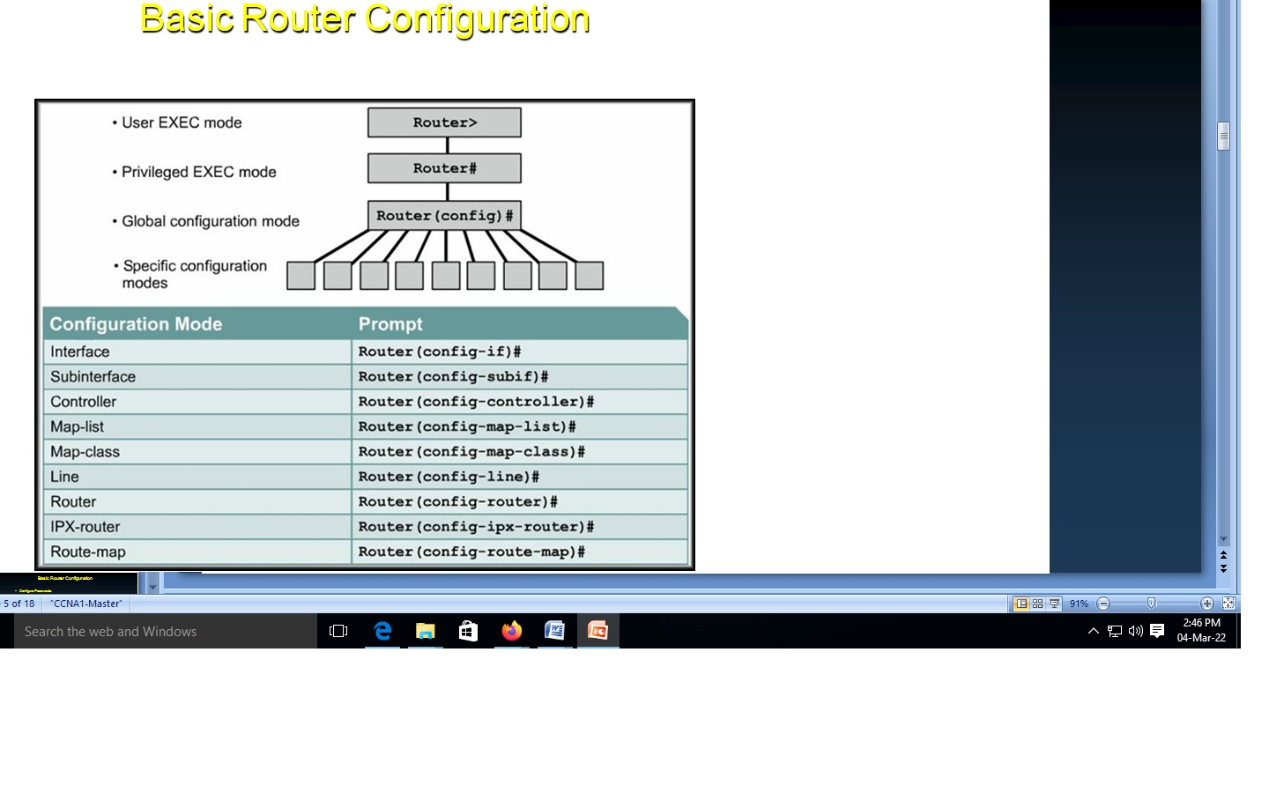

Basic Router Configuration – R1:

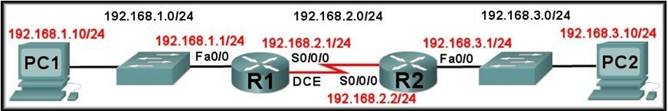

WAN Interface Configuration
R1(config)#interface Serial0/0/0
R1(config-if)#ip address 192.168.2.1 255.255.255.0
R1(config-if)#description Link to R2
R1(config-if)#clockrate 64000 (DCE Only)
R1(config-if)#no shutdown

- LAN Interface Configuration:
R1(config)#interface FastEthernet0/0
R1(config-if)#ip address 192.168.1.1 255.255.255.0
R1(config-if)#description R1 LAN
R1(config-if)#no shutdown

Each Interface Belongs to a Separate Network:
R1(config)#interface FastEthernet0/1
R1(config-if)#ip address 192.168.1.2 255.255.255.0
192.168.1.0 overlaps with FastEthernet0/0
R1(config-if)#no shutdown
192.168.1.0 overlaps with FastEthernet0/0
FastEthernet0/1: incorrect IP address

--------------------------------------------------------------------------------------------------

Output:

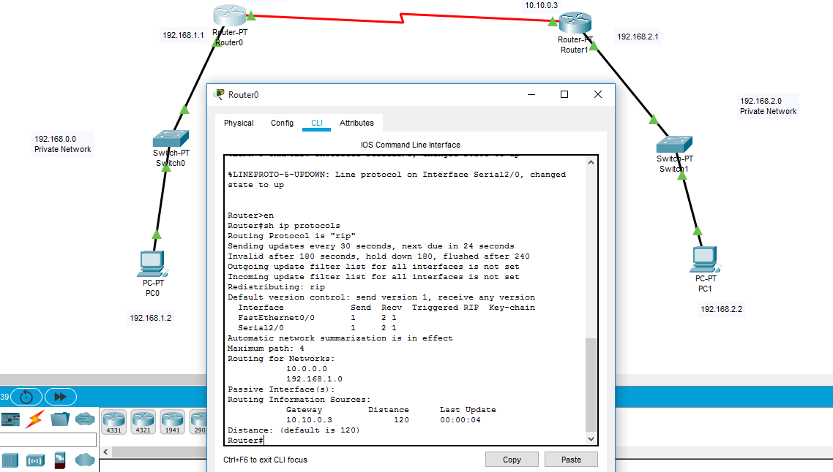

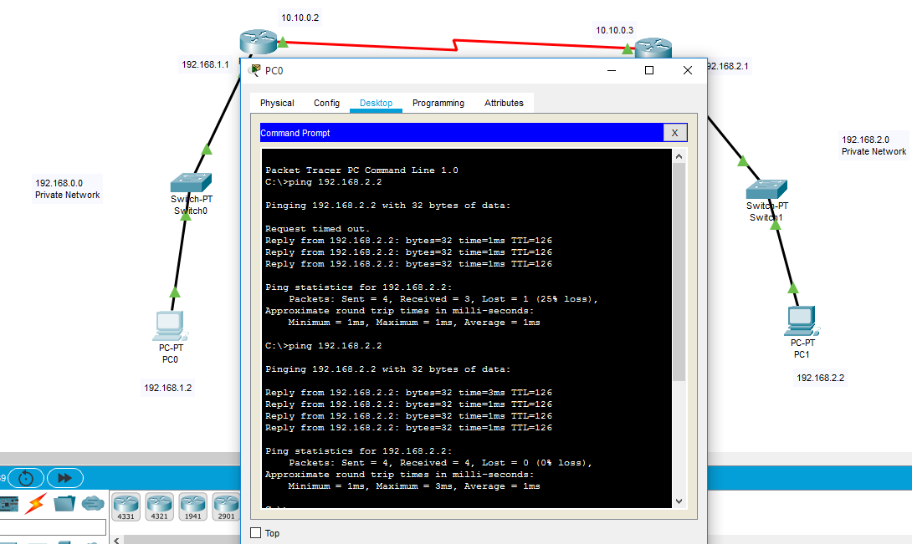

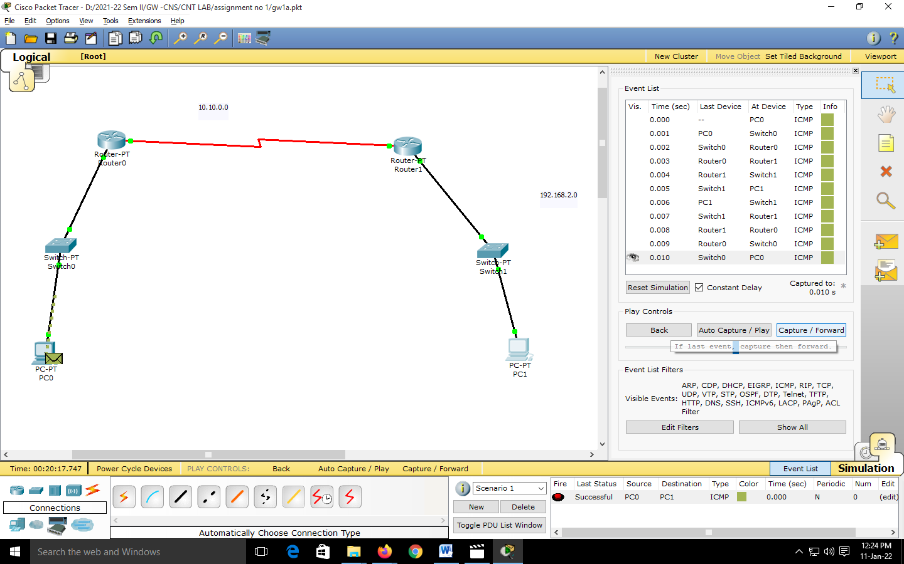

Experiment No 1(B)

Title: Using a Network Simulator (e.g. packet tracer) Configure Router for…
a) Configure Access Control lists – Standard & Extended.

Aim: Design a network using Network Simulator (Packet Tracer) and
Configure Router for Access Control lists – Standard & Extended

Objective : To learn to use packet tracer to design network and configuring the router

for Access Control lists – Standard & Extended

Theory:

Access control list
ACLs are basically a set of commands, grouped together by a number or name that is used to filter traffic entering or leaving an interface.
When activating an ACL on an interface, you must specify in which direction the traffic should be filtered:
- Inbound (as the traffic comes into an interface)
- Outbound (before the traffic exits an interface)
Inbound ACLs: Incoming packets are processed before they are routed to an outbound interface. An inbound ACL is efficient because it saves the overhead of routing lookups if the packet will be discarded after it is denied by the filtering tests. If the packet is permitted by the tests, it is processed for routing.
Outbound ACLs: Incoming packets are routed to the outbound interface and then processed through the outbound ACL.

Universal fact about Access control list
- ACLs come in two varieties : Numbered and named
- Each of these references to ACLs supports two types of filtering: standard and extended.
- Standard IP ACLs can filter only on the source IP address inside a packet.
- Whereas an extended IP ACLs can filter on the source and destination IP addresses in the packet.
- There are two actions an ACL can take: permit or deny.
- Statements are processed top-down.
- Once a match is found, no further statements are processed—therefore, order is important.
- If no match is found, the imaginary implicit deny statement at the end of the ACL drops the packet.
- An ACL should have at least one permit statement; otherwise, all traffic will be dropped because of the hidden implicit deny statement at the end of every ACL.
No matter what type of ACL you use, though, you can have only one ACL per protocol, per interface, per direction. For example, you can have one IP ACL inbound on an interface and another IP ACL outbound on an interface, but you cannot have two inbound IP ACLs on the same interface.
Access List Ranges

Type | Range
IP Standard | 1–99
IP Extended | 100–199
IP Standard Expanded Range | 1300–1999
IP Extended Expanded Range | 2000–2699

Standard ACLs
A standard IP ACL is simple; it filters based on source address only. You can filter a source network or a source host, but you cannot filter based on the destination of a packet, the particular protocol being used such as the Transmission Control Protocol (TCP) or the User Datagram Protocol (UDP), or on the port number. You can permit or deny only source traffic.

Extended ACLs:
An extended ACL gives you much more power than just a standard ACL. Extended IP ACLs check both the source and destination packet addresses. They can also check for specific protocols, port numbers, and other parameters, which allow administrators more flexibility and control.

Configuration Guidelines
- Order of statements is important: put the most restrictive statements at the top of the list and the least restrictive at the bottom.
- ACL statements are processed top-down until a match is found, and then no more statements in the list are processed.
- If no match is found in the ACL, the packet is dropped (implicit deny).
- Each ACL needs either a unique number or a unique name.
- The router cannot filter traffic that it, itself, originates.
- You can have only one IP ACL applied to an interface in each direction (inbound and outbound)—you can't have two or more inbound or outbound ACLs applied to the same interface. (Actually, you can have one ACL for each protocol, like IP and IPX, applied to an interface in each direction.)
- Applying an empty ACL to an interface permits all traffic by default: in order for an ACL to have an implicit deny statement, you need at least one actual permit or deny statement.
- Remember the numbers you can use for IP ACLs.Standard ACLs can use numbers ranging 1–99 and 1300–1999, and extended ACLs can use 100–199 and 2000–2699.
- Wildcard mask is not a subnet mask. Like an IP address or a subnet mask, a wildcard mask is composed of 32 bits when doing the conversion; subtract each byte in the subnet mask from 255.
There are two special types of wildcard masks:
0.0.0.0 and 255.255.255.255
A 0.0.0.0 wildcard mask is called a host mask
255.255.255.255. If you enter this, the router will cover the address and mask to the keyword any.

Placement of ACLs
Standard ACLs should be placed as close to the destination devices as possible.
Extended ACLs should be placed as close to the source devices as possible.

Standard access lists
Because a standard access list filters only traffic based on source traffic, all you need is the IP address of the host or subnet you want to permit or deny. ACLs are created in global configuration mode and then applied on an interface. The syntax for creating a standard ACL is
access-list {1-99 | 1300-1999} {permit | deny} source-address
[wildcard mask]
In this article we will configure standard access list. If you want read the feature and characteristic of access list reads this previous article.

Access control list
In this article we will use a RIP running topology. Which we created in RIP routing practical.

Well-Known Port Numbers and IP Protocols
Port Number | IP Protocol
20 (TCP) | FTP data
21 (TCP) | FTP control
23 (TCP) | Telnet
25 (TCP) | Simple Mail Transfer Protocol (SMTP)
53 (TCP/UDP) | Domain Name System (DNS)
69 (UDP) | TFTP
80 (TCP) | HTTP
In this article we will configure Extended access list. If you want to read the feature and
Output of Standard ACL:

To Check Output, Click on PC with 192.168.1.3 ip and in command prompt write-
PC> ping 192.168.2.3
It shows time out as follows.
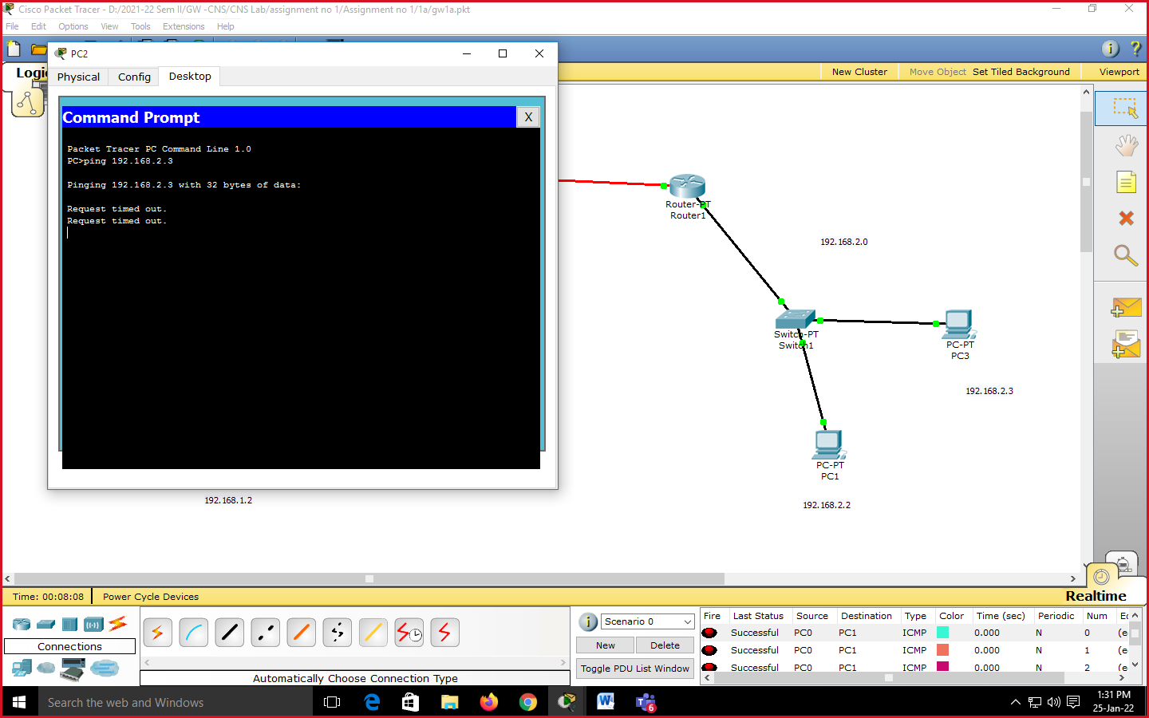

------------------------------------------------------------------------------------------------------------

Extended ACL

Router>en
Router#conf t
Enter configuration commands, one per line. End with CNTL/Z.
Router(config)#access-list 101 deny ip host 192.168.3.4 192.168.4.3 0.0.0.0
Router(config)#access-list 101 permit ip any any
Router(config)#interface fastEthernet1/0
Router(config-if)#ip access-group 101 in
Router(config-if)#exit
Router(config)#
%SYS-5-CONFIG_I: Configured from console by console
Router#

Output of Extended ACL :
To check out put go to PC with 192.168.3.4 and ping
PC> ping 192.168.4.3
It will show following time out output.
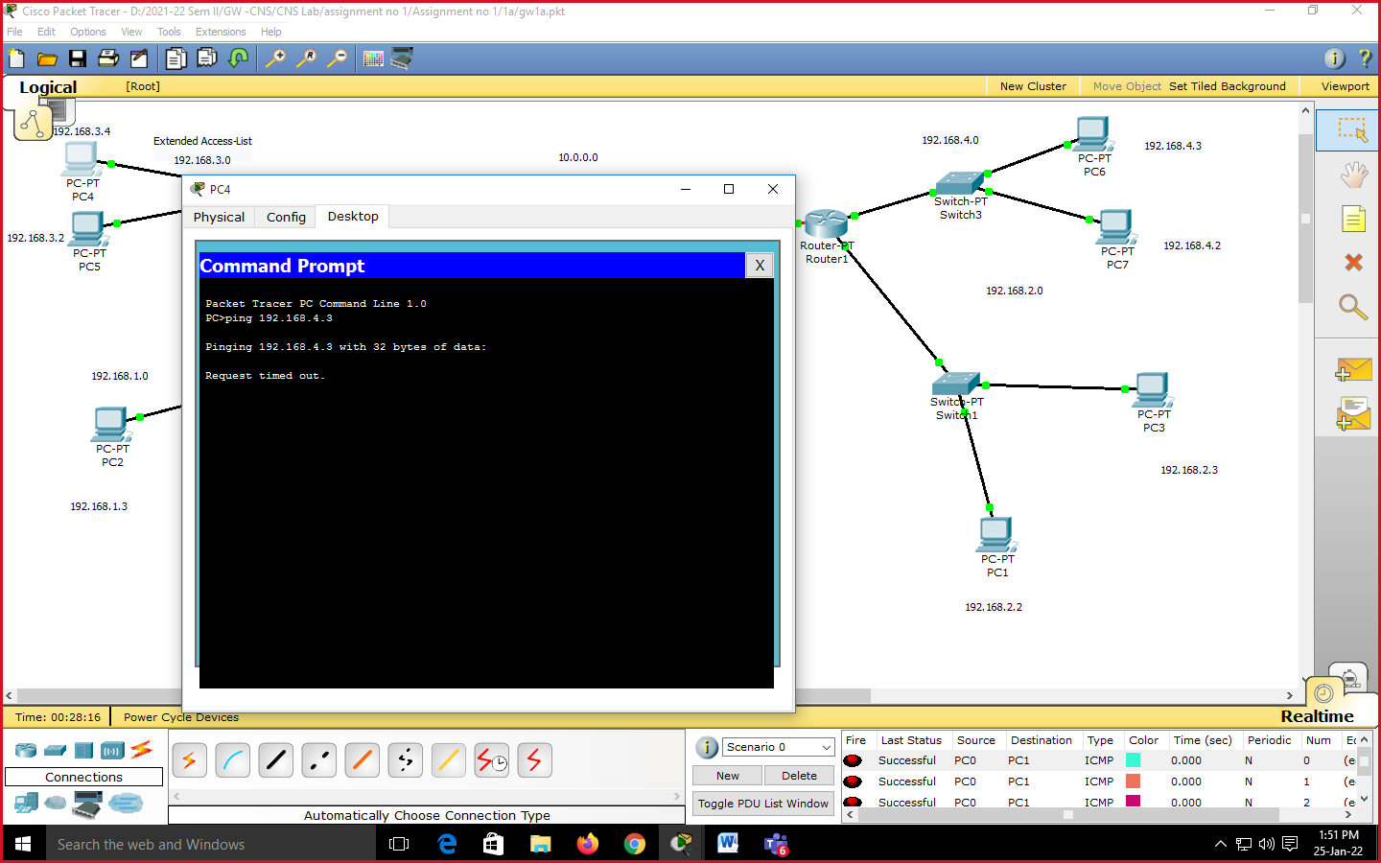

Conclusion: Configured the router for standard and extended access list.

Experiment No 1(C)

Title: Using a Network Simulator (e.g. packet tracer) Configure Router for…
a) Network Address Translation: Static, Dynamic & PAT (Port Address Translation)

Aim: Design a network using Network Simulator (Packet Tracer) and Configure Router for NAT

Objective : To learn to use packet tracer to design network and configuring the router for NAT.

Theory:
To access the Internet, one public IP address is needed, but we can use a private IP address in our private network. The idea of NAT is to allow multiple devices to access the Internet through a single public address. To achieve this, the translation of a private IP address to a public IP address is required. Network Address Translation (NAT) is a process in which one or more local IP address is translated into one or more Global IP address and vice versa in order to provide Internet access to the local hosts. Also, it does the translation of port numbers i.e. masks the port number of the host with another port number, in the packet that will be routed to the destination. It then makes the corresponding entries of IP address and port number in the NAT table. NAT generally operates on a router or firewall.
Network Address Translation (NAT) working –
Generally, the border router is configured for NAT i.e the router which has one interface in the local (inside) network and one interface in the global (outside) network. When a packet traverse outside the local (inside) network, then NAT converts that local (private) IP address to a global (public) IP address. When a packet enters the local network, the global (public) IP address is converted to a local (private) IP address.
If NAT runs out of addresses, i.e., no address is left in the pool configured then the packets will be dropped and an Internet Control Message Protocol (ICMP) host unreachable packet to the destination is sent.

NAT is a router function where IP addresses (and possibly port numbers) of IP datagrams are replaced at the boundary of a private network.
NAT is a method that enables hosts on private networks to communicate with hosts on the Internet.
NAT is run on routers that connect private networks to the public Internet, to replace the IP address-port pair of an IP packet with another IP address-port pair.

NAT inside and outside addresses –
Inside refers to the addresses which must be translated. Outside refers to the addresses which are not in control of an organization. These are the network Addresses in which the translation of the addresses will be done.

• Inside local address – An IP address that is assigned to a host on the Inside (local) network. The address is probably not an IP address assigned by the service provider i.e., these are private IP addresses. This is the inside host seen from the inside network.
• Inside global address – IP address that represents one or more inside local IP addresses to the outside world. This is the inside host as seen from the outside network.
• Outside local address – This is the actual IP address of the destination host in the local network after translation.
• Outside global address – This is the outside host as seen from the outside network. It is the IP address of the outside destination host before translation.

Network Address Translation (NAT) Types –
There are 3 ways to configure NAT:
- Static NAT – In this, a single unregistered (Private) IP address is mapped with a legally registered (Public) IP address i.e one-to-one mapping between local and global addresses. This is generally used for Web hosting. These are not used in organizations as there are many devices that will need Internet access and to provide Internet access, a public IP address is needed.
Suppose, if there are 3000 devices that need access to the Internet, the organization has to buy 3000 public addresses that will be very costly.
- Dynamic NAT – In this type of NAT, an unregistered IP address is translated into a registered (Public) IP address from a pool of public IP addresses. If the IP address of the pool is not free, then the packet will be dropped as only a fixed number of private IP addresses can be translated to public addresses.
Suppose, if there is a pool of 2 public IP addresses then only 2 private IP addresses can be translated at a given time. If 3rd private IP address wants to access the Internet then the packet will be dropped therefore many private IP addresses are mapped to a pool of public IP addresses. NAT is used when the number of users who want to access the Internet is fixed. This is also very costly as the organization has to buy many global IP addresses to make a pool.
- Port Address Translation (PAT) – This is also known as NAT overload. In this, many local (private) IP addresses can be translated to a single registered IP address. Port numbers are used to distinguish the traffic i.e., which traffic belongs to which IP address. This is most frequently used as it is cost-effective as thousands of users can be connected to the Internet by using only one real global (public) IP address.
Advantages of NAT –
- NAT conserves legally registered IP addresses.
- It provides privacy as the device’s IP address, sending and receiving the traffic, will be hidden.
- Eliminates address renumbering when a network evolves.
Disadvantage of NAT –
- Translation results in switching path delays.
- Certain applications will not function while NAT is enabled.
- Complicates tunneling protocols such as IPsec.
- Also, the router being a network layer device, should not tamper with port numbers(transport layer) but it has to do so because of NAT.

Our Practical Example :

Static NAT

Now we will use static NAT configuration as follows-
Click on Router 0 and enter following commands-
Router#conf t
Enter configuration commands, one per line. End with CNTL/Z.
Router(config)#ip nat inside source static 192.168.1.2 10.10.0.2
//This means that 192.168.1.2 is inside LAN private address of PC and 10.10.0.2 is WAN Public address ip address. We map this private ip to this Public ip using static routing.

Router(config)#int Serial2/0
Router(config-if)#ip nat outside // configuring WAN interface which is outside

Router(config-if)#interface fastethernet0/0
Router(config-if)#ip nat in // configuring LAN interface which is inside
Router(config-if)#

Output of Static NAT-

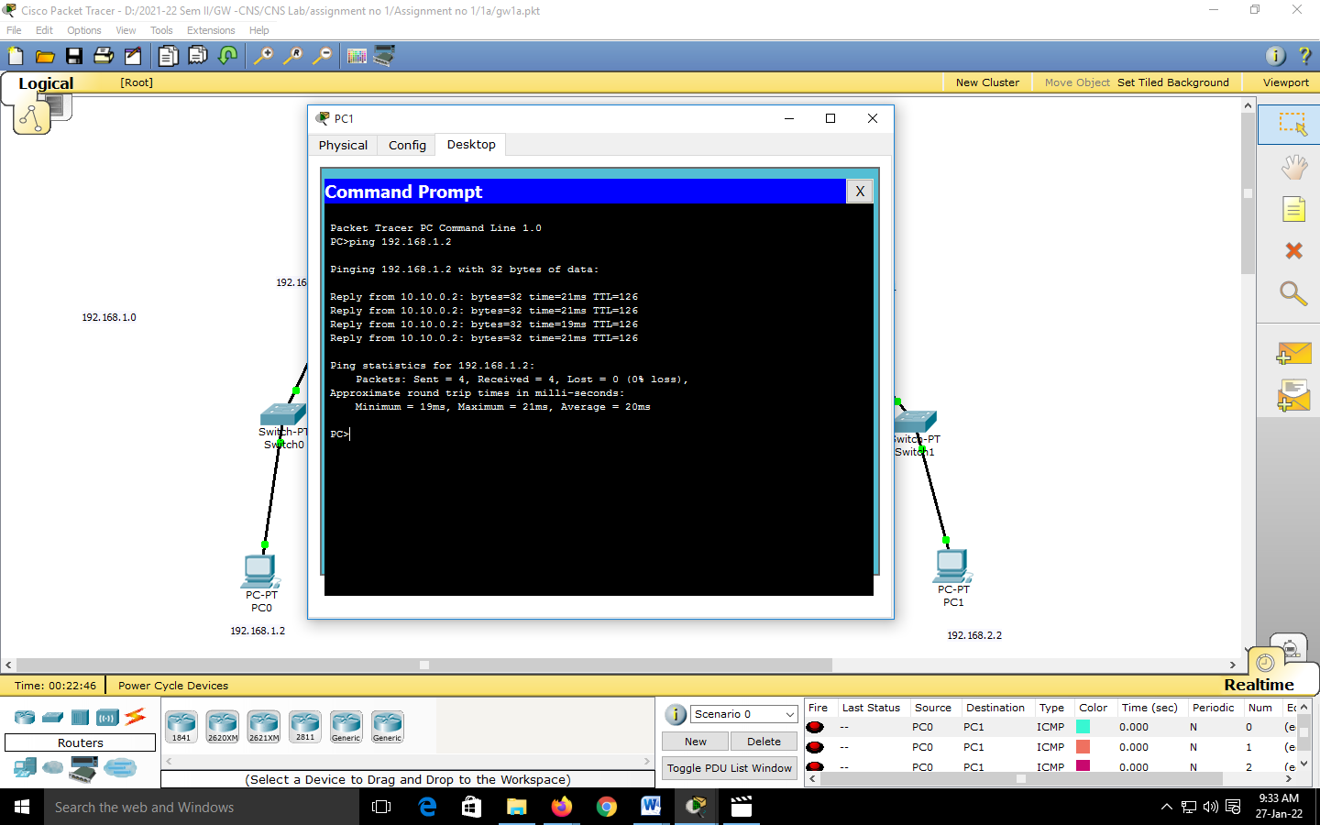

One more output:
-----------------------------------------------------------------------

You can also use following command to ensure Static NAT working
Router#sh ip nat tr
Pro Inside global Inside local Outside local Outside global
--- 10.10.0.2 192.168.1.2 --- ---

------------------------------------------------------------------------------------------------------------

Our Practical Example:
Dynamic NAT

Now we will use Dynamic routing as follows-
Click on Router 0 and enter following commands-
Router#conf t
Router(config)#access-list 1 host permit 192.168.1.0
Router(config)#ip nat pool gmwnat 10.10.0.4 10.10.0.8 netmask 255.0.0.0
// gmwnat is name of the pool
Router(config)#ip nat inside source list 1 pool gmwnat
// inside source is access-list1 i.e. 192.168.1.0 and outside is pool of public ips as specified.

Router(config)#int serial2/0
Router(config-if)#ip nat outside
Router(config-if)#int fa0/0
Router(config-if)#ip nat inside
Router(config-if)#

Output of Dynamic NAT:

Router#sh ip nat tr
Pro Inside global Inside local Outside local Outside global
--- 10.10.0.2 192.168.1.2 --- ---

-----------------------------------------------------------------------------------------------------------
Our Practical Example:
PAT

Output of PAT:

Now Debugg start
company#debug ip nat
IP NAT debugging is on
company#
company#

Side by side click on PC1 and ping 5.0.0.1

Output is as follows-
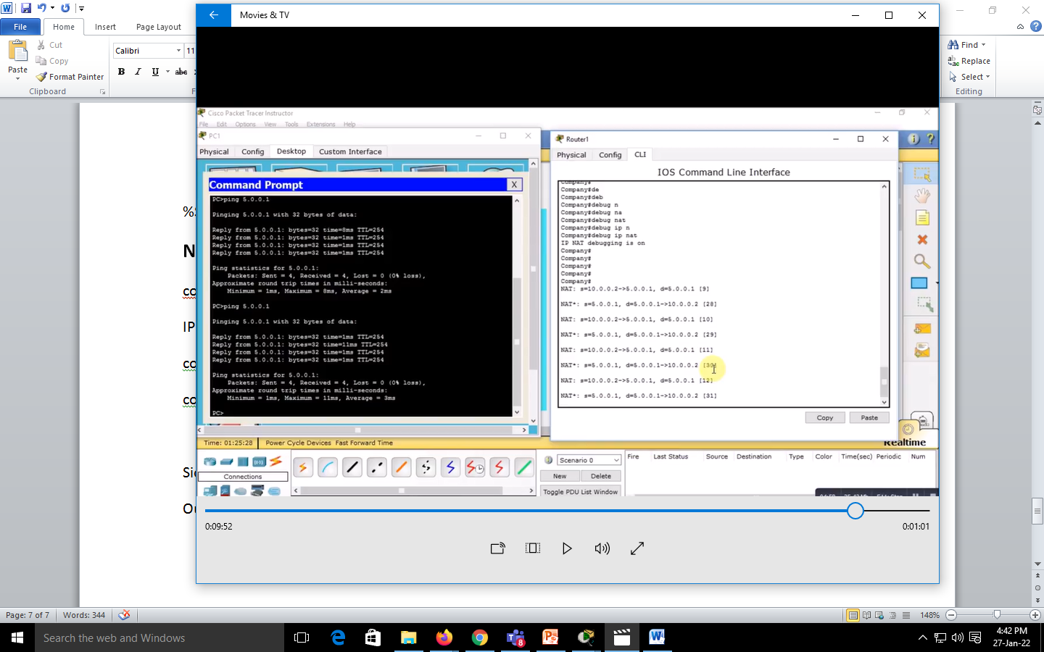

------------------------------------------------------------------------------------------------------------

Experiment No. 2

Experiment No. 2(A)

Title: Using a Network Simulator (e.g. packet tracer) Configure Routing Protocols,
  - Configure EIGRP – Explore Neighbor-ship Requirements and Conditions, its K Values Metrics Assignment and Calculation.

Aim :Study and configuration of EIGRP routing protocol.

Objective: configuration of EIGRP routing protocol using Packet Tracer.

Theory :

Introduction to EIGRP
Enhanced Interior Gateway Routing Protocol or EIGRP automates the routing decisions and configurations in computer networking. Cisco designed the protocol and is available only on Cisco routers. Minimum bandwidth is used from the source to destination, and the delay is measured using metrics of the network. This is an advanced protocol to measure the distance and uses both link servicing and distance routing. Hence it is called a hybrid protocol. It transitions well with IPv6 and has the support of IPv4 as well. This is a classless routing technique. Two routers are connected, and the network is shared in EIGRP.

What is EIGRP?
Enhanced Interior Gateway Routing Protocol is an advanced distance vector routing protocol based on the principles of the Interior Gateway Routing Protocol (IGRP). It has a unique characteristic that improves the operational ability and fast converging rate. It can determine the shortest path distance vector, and it works on the principle of Interior Gateway Routing Protocol, a classless routing protocol. It uses metrics like bandwidth, load and delays to calculate the shortest optimal network route. It is a technologically, more advanced distance vector-based routing protocol. To exchange information using EIGRP, first and foremost, the routers need to become neighbors to EIGRP, then EIGRP uses the multicast address to share the information.

Fundamentals of EIGRP
Enhanced Interior Gateway Routing Protocol (EIGRP) is a dynamic routing protocol used for routers’ decisions and configuration. EIGRP only sends incremental updates, which in short reduces the workload of the routers and the amount of information transmitted. EIGRP is a classic hybrid protocol that supports classless routing, it supports automatic & manual summarization on an EIGRP enabled interface. It MD5 authentication on routers running EIGRP and also has a maximum hop count close to 255. EIGRP performs load balancing over the equal-cost path and un-equal cost path.
To perform the functions of EIGRP, it creates three tables which are:
- Neighbor Table
- Topology Table
- Routing Table
Following represents the ideology and concepts behind the three major tables:

1. Neighbor Table
- The neighbor table contains information about routers and neighborship relationships with those whom have been established.
- Command to list router information: ‘show ip eigrp neighbors’.
- The Neighbor Table has Fields like H: Handle, Address, Interface, Hold Time, Uptime, Smooth Round Trip Time, Retransmission Timeout, Queue Count, Sequence Number.

2. Topology Table
- The topology table holds information about all the paths to networks understood by EIGRP routers.
- Command to list router information- ‘show ip eigrp’ topology.
- The topology table holds the following fields Passive, Feasible Distance, Advertised distance, Feasible distance

3. Routing Table
- The routing table stores the routes which are currently active in sending packets to the network. It stores the optimal route for the destination from the sender.
- Command to List Router Information: ’show ipv6 route’.
- The routing table holds the following fields D, 90/ 5632. Via 11.0.0.2, GigabitEthernet0/1.

Benefits of EIGRP
- Enhanced Interior Gateway Routing Protocol converges at fast rapid times for the changes in the network topology.
- It makes use of link more effectively through (ECMP) Equal-Cost Multi-Path and unequal cost load sharing.
- It performs a much easier transition with a multi-address family.
- It supports both IPV4 and IPV6 networks.
- It provides encryption for security and can be used with iBGP for WAN routing.
- It reduces network traffic by making use of ‘need-based’ updates
- Enhanced Interior Gateway Routing Protocol(EIGRP) is an advanced distance-vector routing protocol that is used on a computer network to help automate routing decisions and configuration.

Pros of EIGRP
- EIGRP with protocol-dependent modules can route several different layer protocols.
- EIGRP configuration was designed to be easy to configure.
- With EIGRP Autonomous number and network command, EIGRP can be enabled.
- EIGRP will converge in 200 milliseconds.
- EIGRP Is the protocol that performs unequal cost load balancing.
- If the destination has more than one link, it will identify the variance between the links.
- One of the more advanced features of EIGRP is Manual route summarization. It improves stability and reduces the routing table size.

Cons of EIGRP
- EIGRP routing protocol can be accessible with the CISCO network devices.
- EIGRP is a distance vector routing protocol, and it relies on routes provided by neighbors.
- It does not support future applications as it is not extensible.

Conclusion
EIGRP is the most advanced routing protocol that relies on distance vector, and state route links are effective in identifying the optimal route path. It will have more impact in real-time as it makes use of required resources, and the only disadvantage is that it is not extensible.

Our Practical Scenario:
Configure EIGRP using Packet Tracer

OUTPUT :

Router#sh ip route
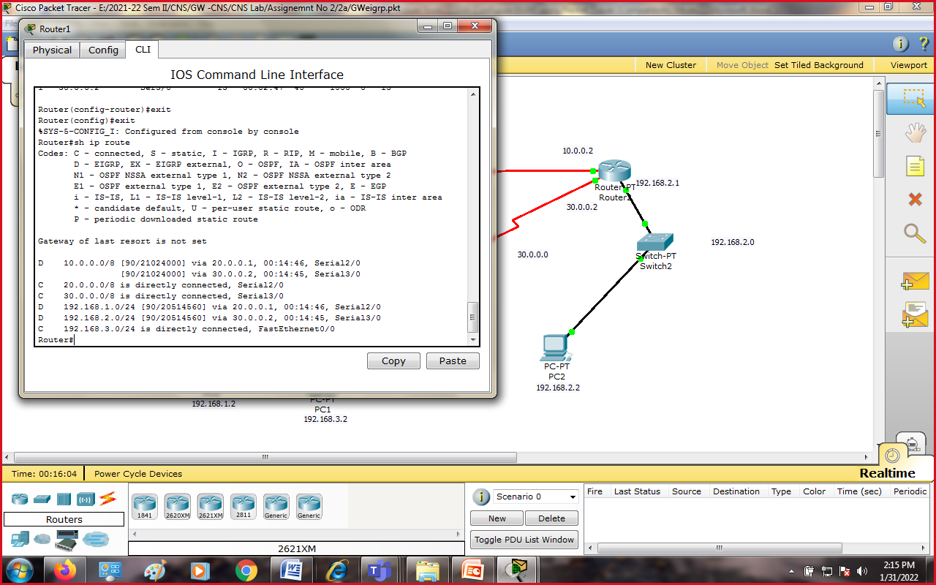
Codes: C - connected, S - static, I - IGRP, R - RIP, M - mobile, B - BGP
D - EIGRP, EX - EIGRP external, O - OSPF, IA - OSPF inter area
N1 - OSPF NSSA external type 1, N2 - OSPF NSSA external type 2
E1 - OSPF external type 1, E2 - OSPF external type 2, E - EGP
i - IS-IS, L1 - IS-IS level-1, L2 - IS-IS level-2, ia - IS-IS inter area
* - candidate default, U - per-user static route, o - ODR
P - periodic downloaded static route

Gateway of last resort is not set

C 10.0.0.0/8 is directly connected, Serial2/0
C 20.0.0.0/8 is directly connected, Serial3/0
D 30.0.0.0/8 [90/21024000] via 20.0.0.2, 00:08:50, Serial3/0
[90/21024000] via 10.0.0.2, 00:07:03, Serial2/0
C 192.168.1.0/24 is directly connected, FastEthernet0/0
D 192.168.2.0/24 [90/20514560] via 10.0.0.2, 00:07:09, Serial2/0
D 192.168.3.0/24 [90/20514560] via 20.0.0.2, 00:07:28, Serial3/0
Router#
Here 90 means Adinistrative distance and 20514560 is the cost.
Updates are coming from 10.0.0.2 i.e. router2.

5. Click on router0 and enter following command to know abt topology.
Router#sh ip eigrp topology
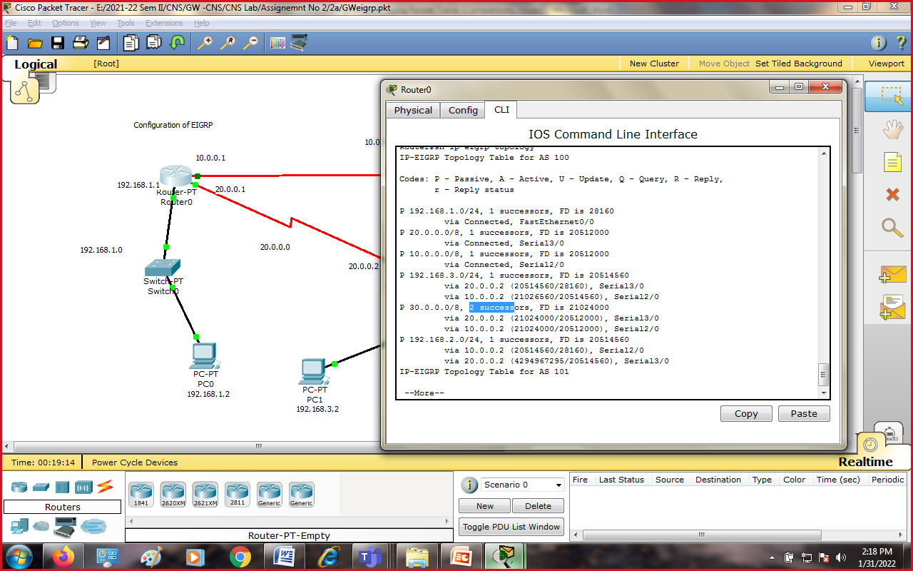
IP-EIGRP Topology Table for AS 100

Codes: P - Passive, A - Active, U - Update, Q - Query, R - Reply,
r - Reply status

P 192.168.1.0/24, 1 successors, FD is 28160
via Connected, FastEthernet0/0
P 10.0.0.0/8, 1 successors, FD is 20512000
via Connected, Serial2/0
P 20.0.0.0/8, 1 successors, FD is 20512000
via Connected, Serial3/0
P 30.0.0.0/8, 2 successors, FD is 21024000
via 20.0.0.2 (21024000/20512000), Serial3/0
via 10.0.0.2 (21024000/20512000), Serial2/0
P 192.168.3.0/24, 1 successors, FD is 20514560
via 20.0.0.2 (20514560/28160), Serial3/0
via 10.0.0.2 (21026560/20514560), Serial2/0
P 192.168.2.0/24, 1 successors, FD is 20514560
via 10.0.0.2 (20514560/28160), Serial2/0
via 20.0.0.2 (21026560/20514560), Serial3/0
Router#
Here note 2 successors at router 0 .
6. Now use show ip protocol command which gives EIGRP metric information like what protocol we are using ,what are K Values,max hopcount,

Router#sh ip protocols
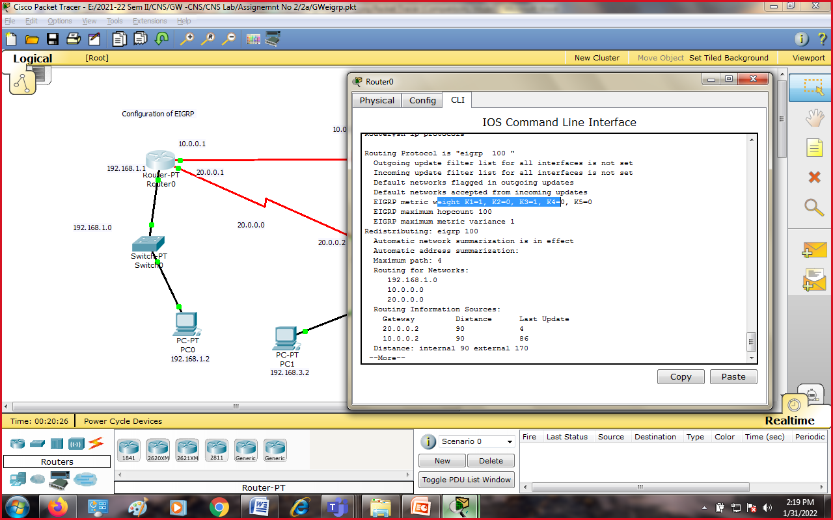

Routing Protocol is "eigrp 100 "
Outgoing update filter list for all interfaces is not set
Incoming update filter list for all interfaces is not set
Default networks flagged in outgoing updates
Default networks accepted from incoming updates
EIGRP metric weight K1=1, K2=0, K3=1, K4=0, K5=0
EIGRP maximum hopcount 100
EIGRP maximum metric variance 1
Redistributing: eigrp 100
Automatic network summarization is in effect
Automatic address summarization:
Maximum path: 4
Routing for Networks:
192.168.1.0
10.0.0.0
20.0.0.0
Routing Information Sources:
Gateway Distance Last Update
20.0.0.2 90 1706607
10.0.0.2 90 1831555
Distance: internal 90 external 170
--More--

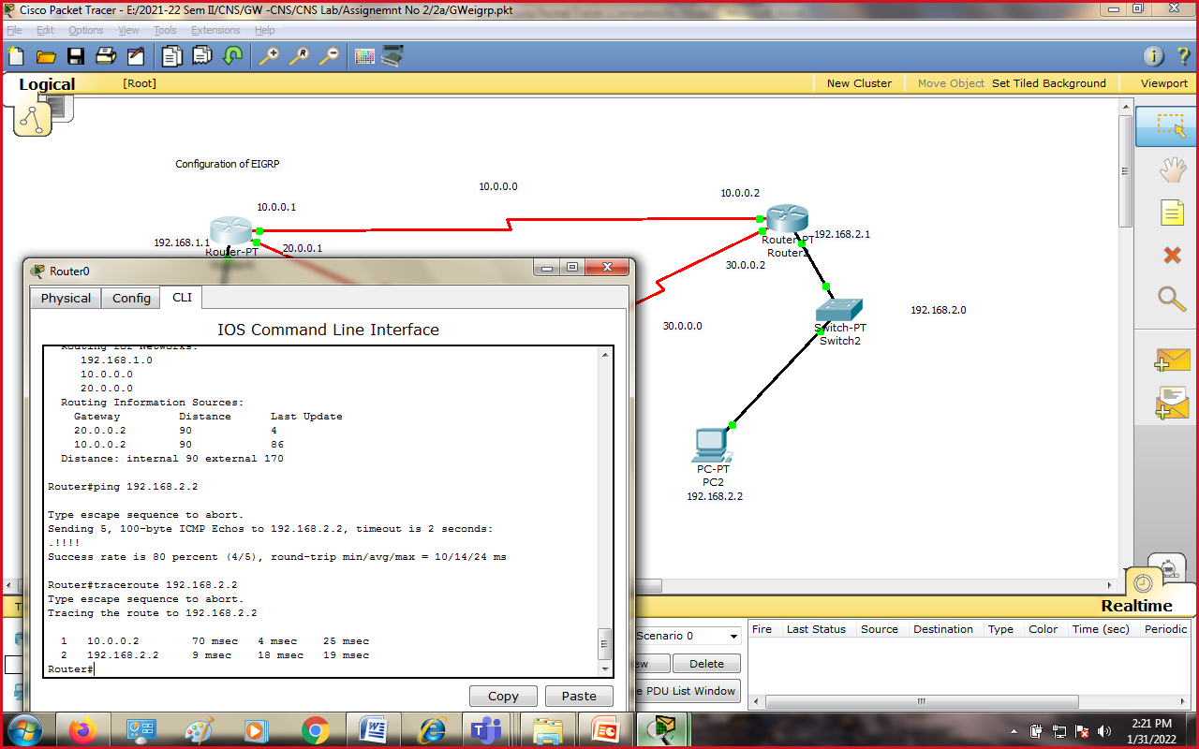

Input: Source Packet
Output : Packet reached to destination using EIGRP.
Conclusion: EIGRP is configured and worked properly using EIGRP routing protocol.

Experiment No. 2(B)

Title: Using a Network Simulator (e.g. packet tracer) Configure Routing Protocols
b) OSPF – Explore Neighbor-ship Condition and Requirement, Neighbor-ship states, OSPF Metric Cost Calculation

Aim :Study and configuration of OSPF routing protocol.

Objective: configuration of OSPF routing protocol using Packet Tracer.

Theory :

OSPF :
Open Shortest Path First (OSPF) is a routing protocol for Internet Protocol (IP) networks. It uses a link state routing (LSR) algorithm and falls into the group of interior gateway protocols (IGPs), operating within a single autonomous system (AS).
OSPF gathers link state information from available routers and constructs a topology map of the network. The topology is presented as a routing table to the Internet Layer for routing packets by their destination IP address. OSPF supports Internet Protocol Version 4 (IPv4) and Internet Protocol Version 6 (IPv6) networks and supports the Classless Inter-Domain Routing (CIDR) addressing model.
OSPF is an interior gateway protocol (IGP) for routing Internet Protocol (IP) packets within a single routing domain, such as an autonomous system. It gathers link state information from available routers and constructs a topology map of the network. The topology is presented as a routing table to the Internet Layer which routes packets based solely on their destination IP address.
OSPF detects changes in the topology, such as link failures, and converges on a new loop-free routing structure within seconds. It computes the shortest-path tree for each route using a method based on Dijkstra's algorithm. The OSPF routing policies for constructing a route table are governed by link metrics associated with each routing interface. Cost factors may be the distance of a router (round-trip time), data throughput of a link, or link availability and reliability, expressed as simple unitless numbers. This provides a dynamic process of traffic load balancing between routes of equal cost.
OSPF divides the network into routing areas to simplify administration and optimize traffic and resource utilization. Areas are identified by 32-bit numbers, expressed either simply in decimal, or often in the same octet-based dot-decimal notation used for IPv4 addresses. By convention, area 0 (zero), or 0.0.0.0, represents the core or backbone area of an OSPF network. While the identifications of other areas may be chosen at will, administrators often select the IP address of a main router in an area as the area identifier. Each additional area must have a connection to the OSPF backbone area. Such connections are maintained by an interconnecting router, known as an area border router (ABR). An ABR maintains separate link-state databases for each area it serves and maintains summarized routes for all areas in the network.
OSPF Characteristics:
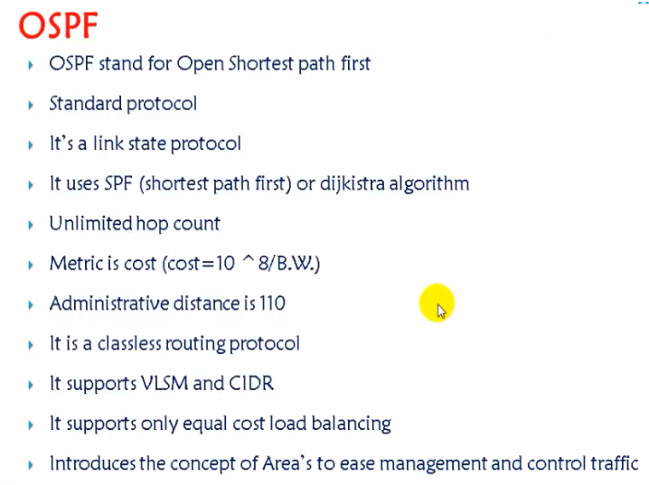
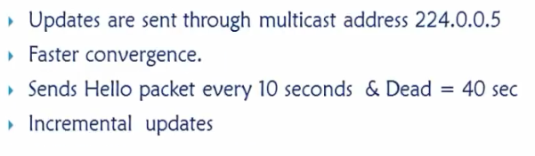

OSPF Basic Process:
The entire OSPF process goes from 7 Stages.
1.Down Stage
2.Init
3.Two-way
4.ExStart
5.Exchange
6.Loading
7.Full

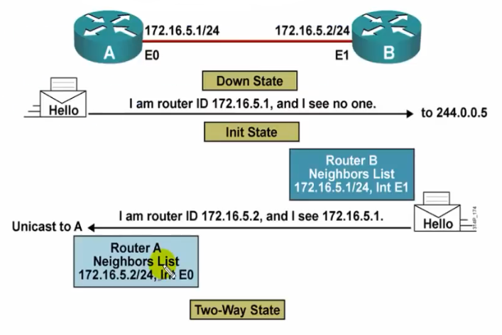
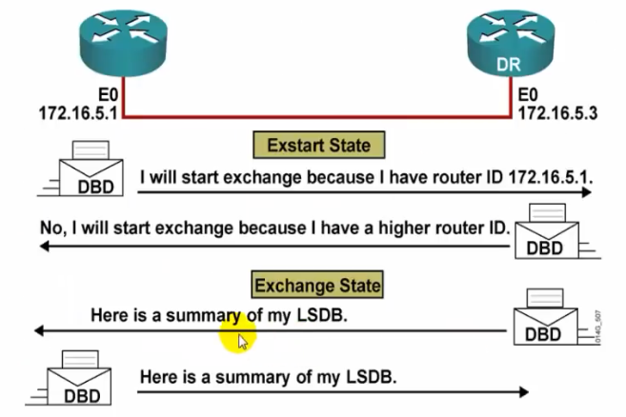

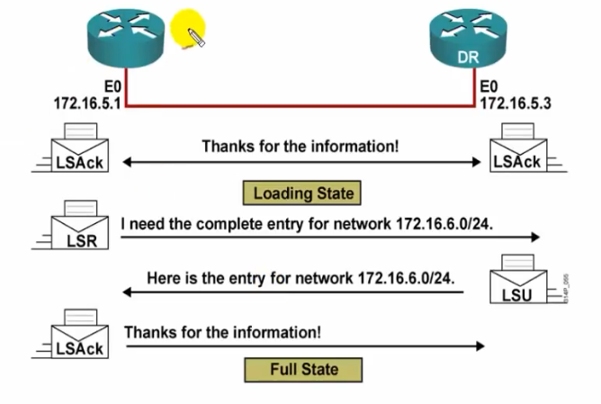

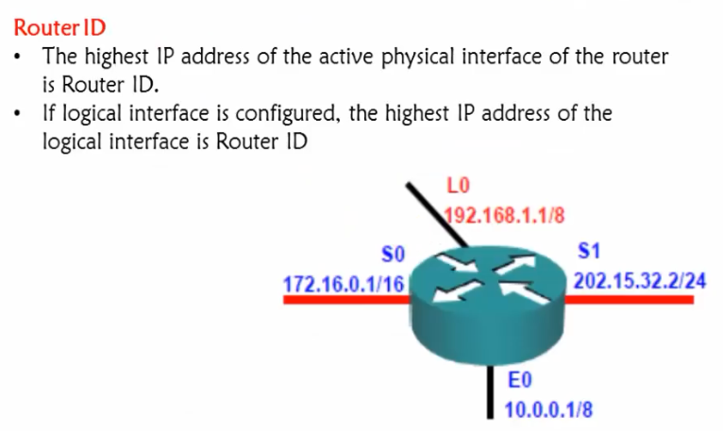

OSPF Tables:
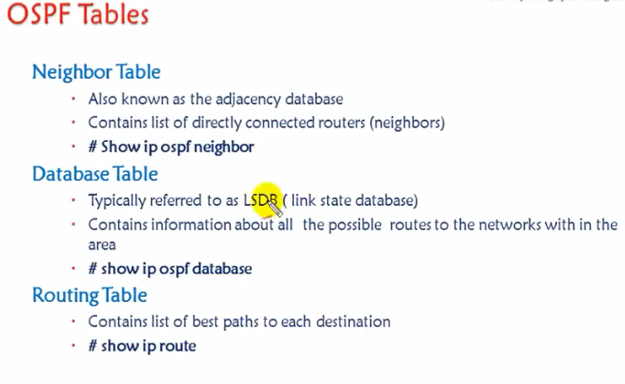

Concept of OSPF Areas:
- All routers must maintain same database.
- Any change impact all the routers
- Area is logical grouping of routers

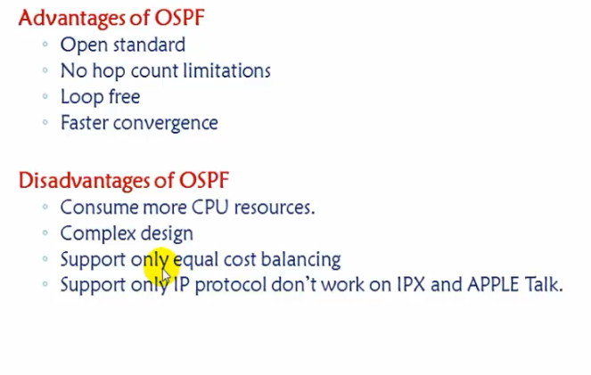

Our Practical Example/Scenario and Steps:

1.Consider following network design
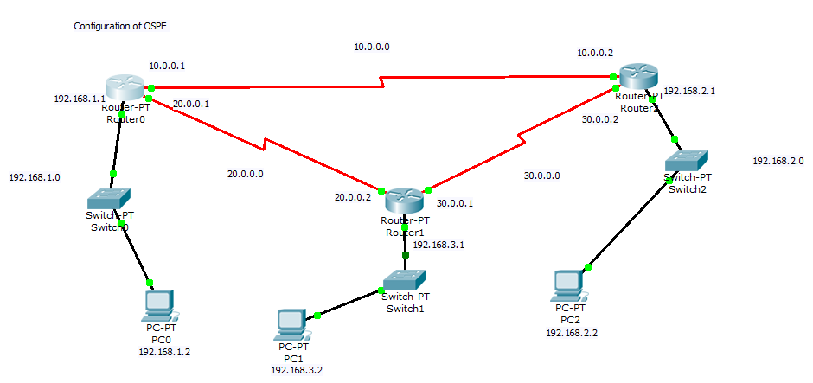

OUTPUTs:

Now to very the neighborship, go to router 1 and very neighborship.
Router#sh ip ospf neighbor
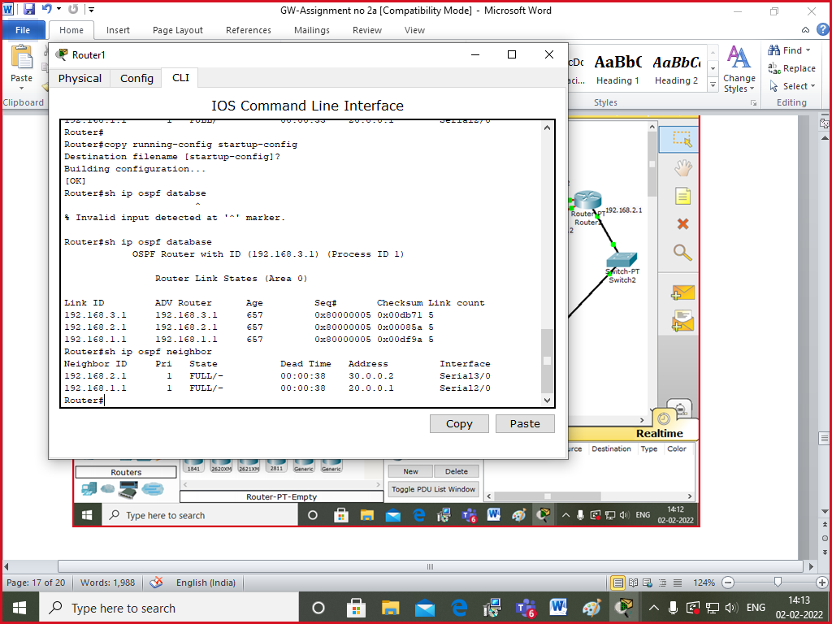
It shows following output-
Neighbor ID Pri State Dead Time Address Interface
192.168.1.1 1 FULL/- 00:00:34 20.0.0.1 Serial2/0
192.168.2.1 1 FULL/- 00:00:39 30.0.0.2 Serial3/0
Router#
Router#
There are two neighbors. Here it takes highest ip address from interfaces. That’s why is 192.168.1.1 and 192.168.2.1 and they are router ids.
4. Now to check the metric and cost
Click on router 0->
Router#sh ip route
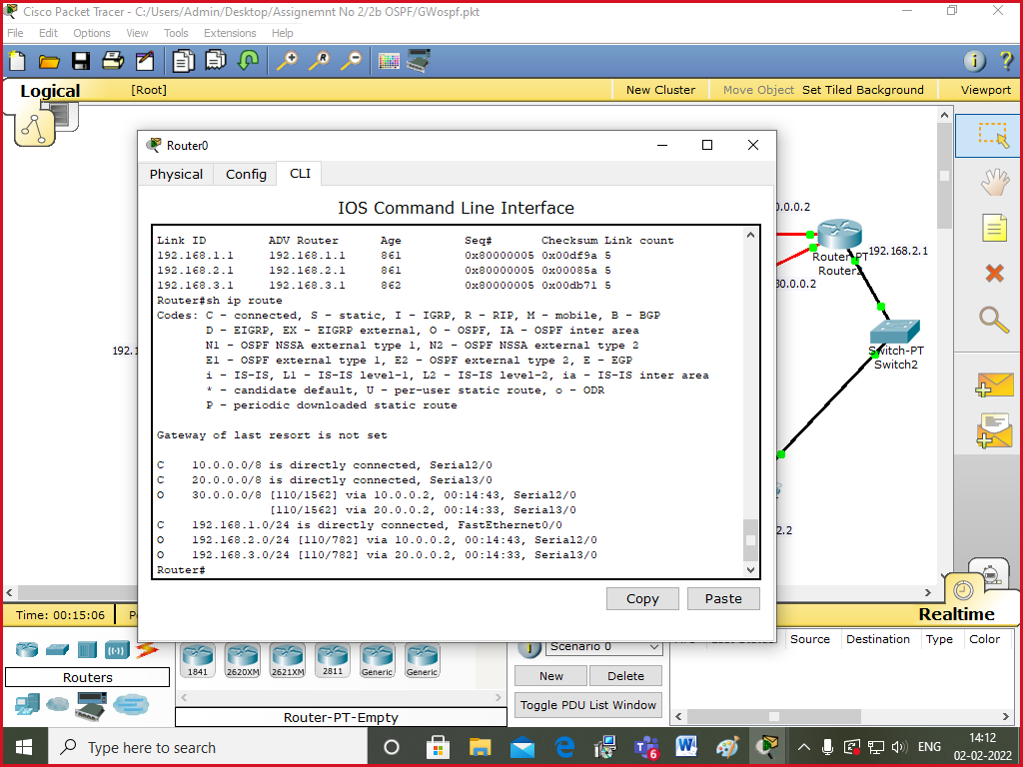

Following output came.
Codes: C - connected, S - static, I - IGRP, R - RIP, M - mobile, B - BGP
D - EIGRP, EX - EIGRP external, O - OSPF, IA - OSPF inter area
N1 - OSPF NSSA external type 1, N2 - OSPF NSSA external type 2
E1 - OSPF external type 1, E2 - OSPF external type 2, E - EGP
i - IS-IS, L1 - IS-IS level-1, L2 - IS-IS level-2, ia - IS-IS inter area
* - candidate default, U - per-user static route, o - ODR
P - periodic downloaded static route

Gateway of last resort is not set

C 10.0.0.0/8 is directly connected, Serial2/0
C 20.0.0.0/8 is directly connected, Serial3/0
O 30.0.0.0/8 [110/1562] via 20.0.0.2, 00:12:50, Serial3/0
[110/1562] via 10.0.0.2, 00:09:08, Serial2/0
C 192.168.1.0/24 is directly connected, FastEthernet0/0
O 192.168.2.0/24 [110/782] via 10.0.0.2, 00:09:19, Serial2/0
O 192.168.3.0/24 [110/782] via 20.0.0.2, 00:13:12, Serial3/0
Router#

Here,
O means it leans through OSPF.
Here ,110 is the administrative distance and 782 is the cost based on bandwidth.
Cost is calculated as 10^8/BW.

5. We can very database table at router0.
Router#sh ip ospf database
This is the output-
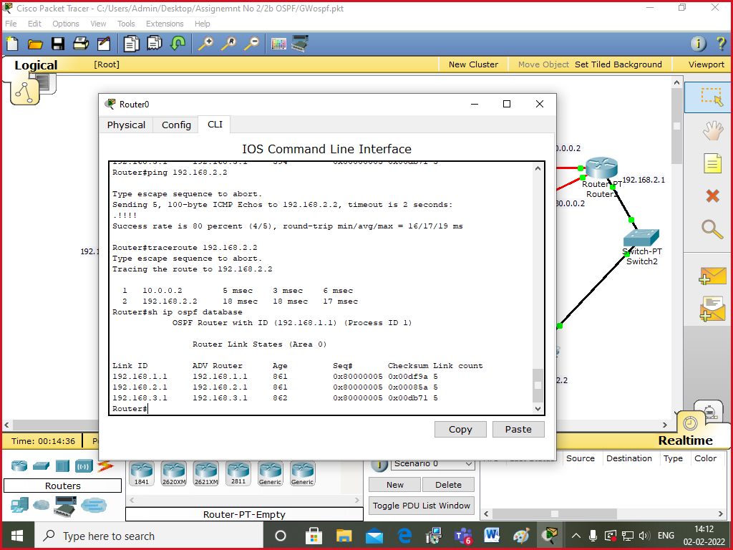
OSPF Router with ID (192.168.1.1) (Process ID 1)

Router Link States (Area 0)

Link ID ADV Router Age Seq# Checksum Link count
192.168.1.1 192.168.1.1 851 0x80000005 0x00d9a0 5
192.168.2.1 192.168.2.1 832 0x80000005 0x00085a 5
192.168.3.1 192.168.3.1 832 0x80000005 0x00bd8f 5
Router#
This means that router 0 belongs to Area 0 , so it maintains the database of area0.
Router id of router 0 is 192.168.1.1 and runs process-id 1.
6. you can go to router0 and ping 192.168.2.2
Router# ping 192.168.2.2
It will show success.
Router#traceroute 192.168.2.2

Output :
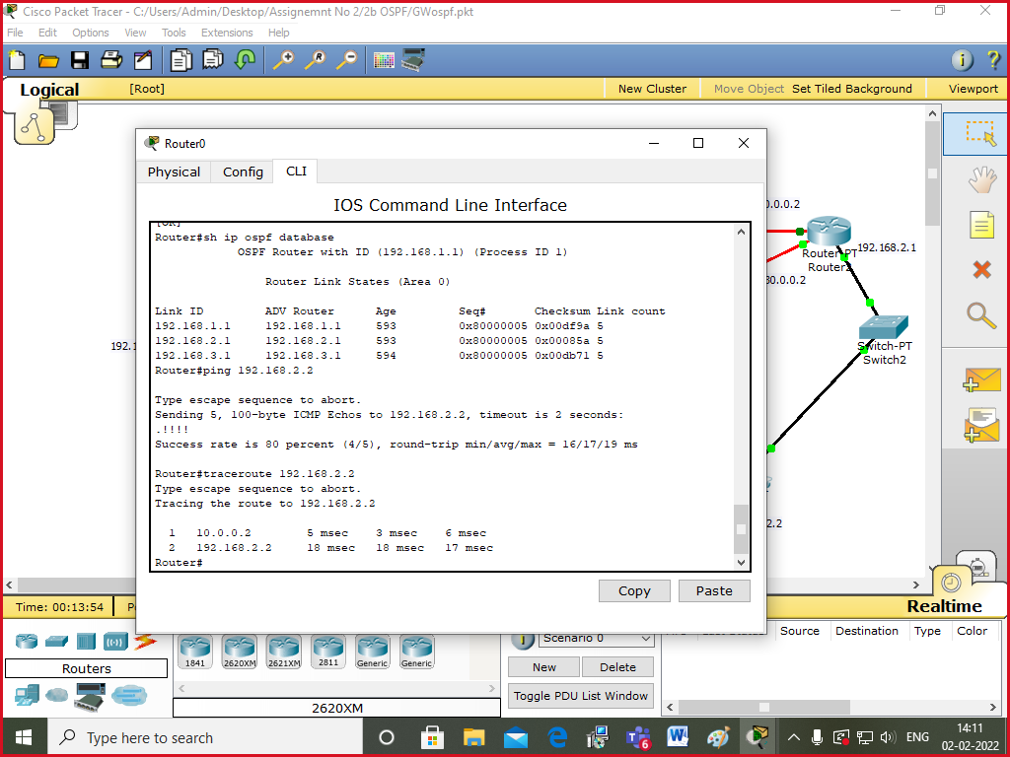

Input: Packet
Output: Packet Reached to destination using OSPF routing protocol giving the route to destination and cost value.
Conclusion: Designed network using packet tracer to configure OSPF routing protocol.

Experiment No. 2(C)

Title: Using a Network Simulator (e.g. packet tracer) Configure Routing Protocols
c) WLAN with static IP addressing and DHCP with MAC security and filters

Aim :Study and configuration of WLAN.

Objective: configuration of WLAN with static IP addressing and DHCP with MAC security and filters

Theory :

Wireless LAN
Wireless LAN stands for “Wireless Local Area Network.” A WLAN, or wireless LAN, is a network that links and communicates wirelessly to computers.

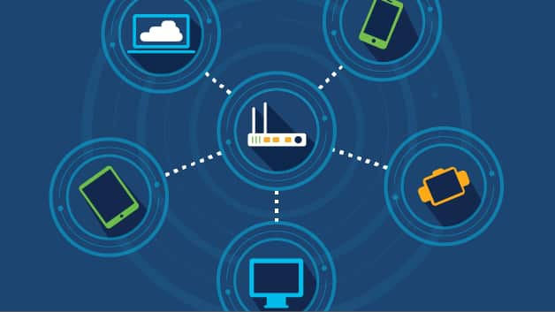

A wireless local-area network (WLAN) is a group of colocated computers or other devices that form a network based on radio transmissions rather than wired connections.
A WLAN can be configured in one of two ways:

Infrastructure
A home or office Wi-Fi network is an example of a WLAN set up in infrastructure mode. The endpoints are all connected and communicate with each other through a base station, which may also provide internet access.
A basic infrastructure WLAN can be set up with just a few parts: a wireless router, which acts as the base station, and endpoints, which can be computers, mobile devices, printers, and other devices. In most cases, the wireless router is also the internet connection.

Ad hoc
In this setup, a WLAN connects endpoints such as computer workstations and mobile devices without the use of a base station. Use of Wi-Fi Direct technology is common for an ad hoc wireless network. An ad hoc WLAN is easy to set up and can provide basic peer-to-peer (P2P) communication.
An ad hoc WLAN requires only two or more endpoints with built-in radio transmission, such as computers or mobile devices. After adjusting network settings for ad hoc mode, one user initiates the network and becomes visible to the others.

Our Practical Example:
Configuration WLAN using Static IP.
Make following network design
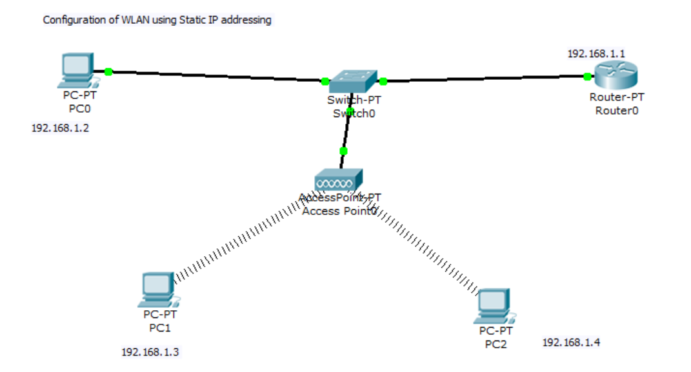

OUTPUT :

Now check the output by
PC1> Ping 192.168.1.4
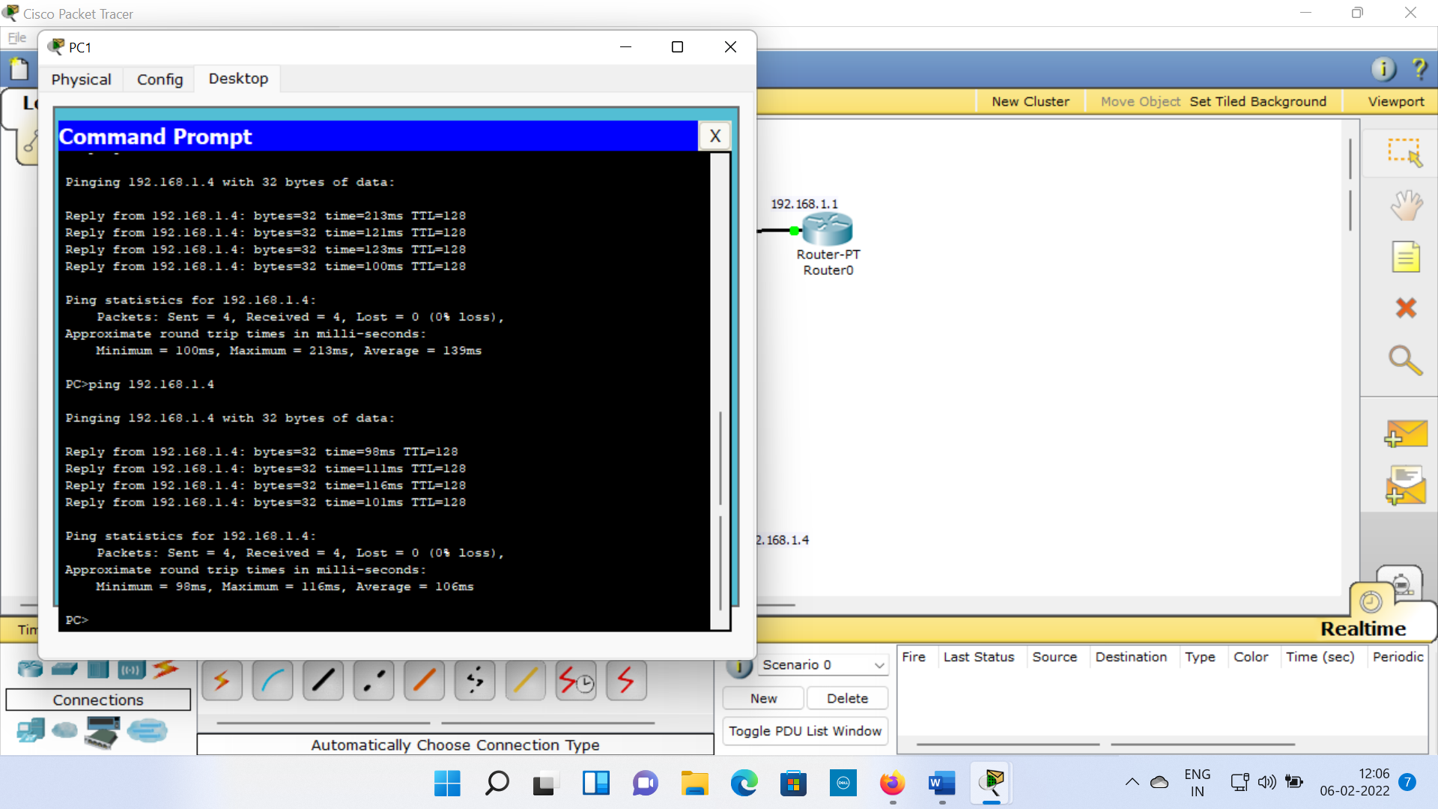

Our Practical Example: WLAN DHCP Configuration
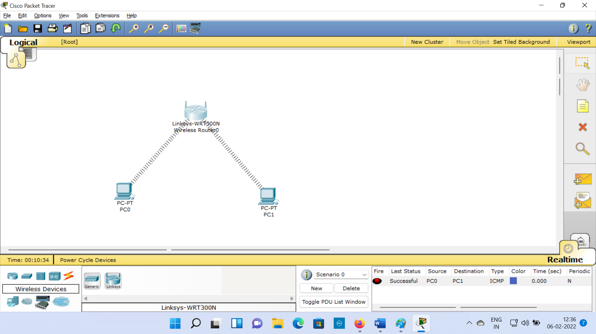

Here u can see 192.168.0.1 is the ip address of the wireless Linksys router0.

Now to apply MAC Filtering
Click on wirless router 0 →Access Restrictions→Wirless MAC Filter ->enable->MAC Address filter list → add MAC address of any wireless PC→save
You will see the link goes away.

Output:
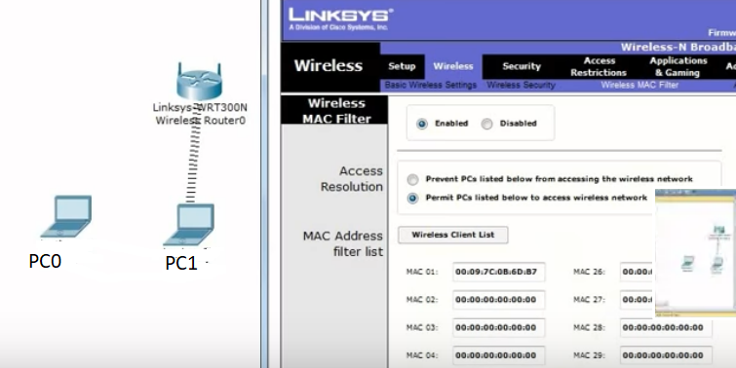

Input: Packet from source to destination
Output: Packet delivered to Destination using WLAN.
Conclusion: WLAN Configures properly using static ip and DHCP.

Experiment No. 3

Title : Socket Programming in C/C++ on Linux. a) TCP Client, TCP Server b) UDP Client, UDP Server
Aim : To study and implement Socket Programming in C/C++ on Linux

Objective : To implement Socket Programming in C/C++ on Linux. a) TCP Client, TCP Server b) UDP Client, UDP Server

Theory :

Socket Programming

What is socket programming?
Socket programming is a way of connecting two nodes on a network to communicate with each other. One socket(node) listens on a particular port at an IP, while other socket reaches out to the other to form a connection. Server forms the listener socket while client reaches out to the server.

Linux System Programming:

Creating TCP server and TCP Client – socket programming in C in Linux

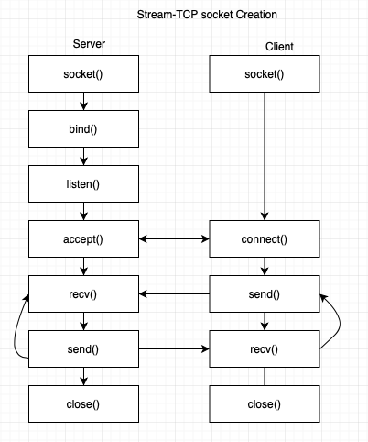
The above image shows the sequence of steps for a Server and client to create a TCP client server communication.

For creating a TCP server:
1. Create a socket using “socket()”
2. bind to an address using “bind()”
3. Listen to the connections using “listen()”
4. Accept the connection using “accept()”
5. Receive the data using “recv()”
6. Send the data using “send()”
7. Close the connection using “close()”

For creating a TCP client:
1. Create a socket using “socket()”
2. Connect to a server using “connect()”
3. Send the data to server using “send()”
4. Receive the data using “recv()”
5. Close the connection using “close()”

Code for TCP server:

#include<stdio.h>
#include<stdlib.h>
#include<sys/types.h>
#include<sys/socket.h>
#include<netinet/in.h>
#include <unistd.h>

int main()
{
int sockfd, clientfd;
struct sockaddr_in serverAddr, cliAddr;
socklen_t addr_size;
int len = sizeof(cliAddr);
char serverMessage[256] = "Hello from server\n";

//create a socket file descriptor
sockfd = socket(PF_INET, SOCK_STREAM, 0);

//fill the serverAddr structure
serverAddr.sin_family = AF_INET;
serverAddr.sin_port = htons(9002);
serverAddr.sin_addr.s_addr = INADDR_ANY;

// bind the address
bind(sockfd, (struct sockaddr *) &serverAddr, sizeof(serverAddr));

// listen
if(listen(sockfd,5)==0)

//accept the connection
clientfd = accept(sockfd, (struct sockaddr *) &cliAddr, &len);

// send the data
send(clientfd,serverMessage,sizeof(serverMessage),0);

close(sockfd);
return 0;
}

Code for TCP client:
#include <stdio.h>
#include <stdlib.h>

#include <sys/types.h>
#include <sys/socket.h>

#include <netinet/in.h>
#include <unistd.h>
#define SIZE 1000

//main functions
int main()
{
int sockfd = socket(AF_INET, SOCK_STREAM, 0);
// server address
struct sockaddr_in serverAddress;
serverAddress.sin_family = AF_INET;
serverAddress.sin_port = htons(9002);
serverAddress.sin_addr.s_addr = INADDR_ANY;

// communicates with listen
connect(sockfd, (struct sockaddr *)&serverAddress, sizeof(serverAddress));

char serverResponse[SIZE];
recv(sockfd, &serverResponse, sizeof(serverResponse), 0);
printf("Received data from server : %s", serverResponse);

//closing the socket
close(sockfd);
return 0;
}
Compile and run both of them in separate tabs. Below will be the output:
Output:
Received data from server : Hello from server

Socket Programming in C in in Linux: Creating UDP Client and UDP Server

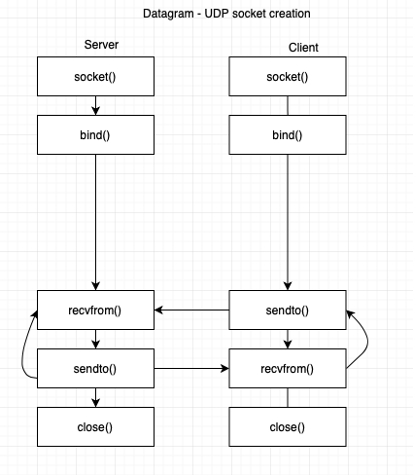
The above image shows the sequence of steps for a Server and client to create a UDP client server communication.
For creating a UDP server:
1. Create a socket using “socket()”
2. bind to an address using “bind()”
3. Wait for the data to be received using “recvfrom()”
4. Send the data to client using “sendto()”
5. Close the connection using “close()”
For creating a UDP client:
1. Create a socket using “socket()”
2. bind to an address using “bind()”
3. Send the data to server using “sendto()”
4. Receive the data from the server using “recvfrom()”
5. Close the connection using “close()”

Code for UDP server:
#include <stdio.h>
#include <stdlib.h>
#include <string.h>
#include <sys/socket.h>
#include <sys/types.h>
#include <netinet/in.h>
#include <arpa/inet.h>

int main( )
{

int port = 1234;
int sockfd;
struct sockaddr_in si_me, si_other;
char buffer[1024];
socklen_t addr_size;

sockfd = socket(AF_INET, SOCK_DGRAM, 0);

memset(&si_me, '\0', sizeof(si_me));
si_me.sin_family = AF_INET;
si_me.sin_port = htons(port);
si_me.sin_addr.s_addr = inet_addr("127.0.0.1");

bind(sockfd, (struct sockaddr*)&si_me, sizeof(si_me));
addr_size = sizeof(si_other);
recvfrom(sockfd, buffer, 1024, 0, (struct sockaddr*)& si_other, &addr_size);
printf("[+]Data Received: %s", buffer);

return 0;
}

Code for UDP client:

#include <stdio.h>
#include <stdlib.h>
#include <string.h>
#include <sys/socket.h>
#include <sys/types.h>
#include <netinet/in.h>
#include <arpa/inet.h>

int main()
{

int port = 1234;
int sockfd;
struct sockaddr_in serverAddr;
char buffer[1024];
socklen_t addr_size;

sockfd = socket(PF_INET, SOCK_DGRAM, 0);
memset(&serverAddr, '\0', sizeof(serverAddr));

serverAddr.sin_family = AF_INET;
serverAddr.sin_port = htons(port);
serverAddr.sin_addr.s_addr = inet_addr("127.0.0.1");

strcpy(buffer, "Hello Server\n");
sendto(sockfd, buffer, 1024, 0, (struct sockaddr*)&serverAddr, sizeof(serverAddr));
printf("[+]Data Send: %s", buffer);

return 0;

}

Output:
[+]Data Received: Hello Server

Conclusion:
Studied the concept of socket programming for TCP Client and Server & UDP Client and Server.

Experiment No. 4

Title: Introduction to server administration (server administration commands and their applications) and configuration of below Server: (Study/Demonstration Only)
a) FTP
b) Web Server

Aim: Study FTP and Web Server

Objective: Configure FTP and Web server using Packet Tracer as well as on machine..

Description: Identify Study in detail working of system/Project & Analysis of Classes and assign responsibilities, Identify Design classes/ Evolve Analysis Model. Use advanced relationships, Draw Design class Model using OCL and UML2.0 Notations, Implement the design model with a suitable object-oriented language.

Theory:

Server Life Cycle

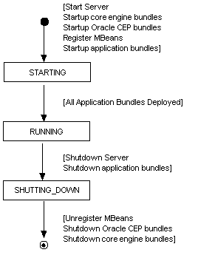

FTP:
FTP is the standard mechanism for sending files from one host to the other.
FTP establishes two connections between the client and the server. One is for data transfer and other is for the control information.
FTP uses port 21 for control connection and port 20 for data connection. .
The control connection is made between the control processes while data connection is made between data transfer processes.
The control connection is maintained during the entire FTP sessions.
The data connection is first opened, file is transferred and data connection is closed

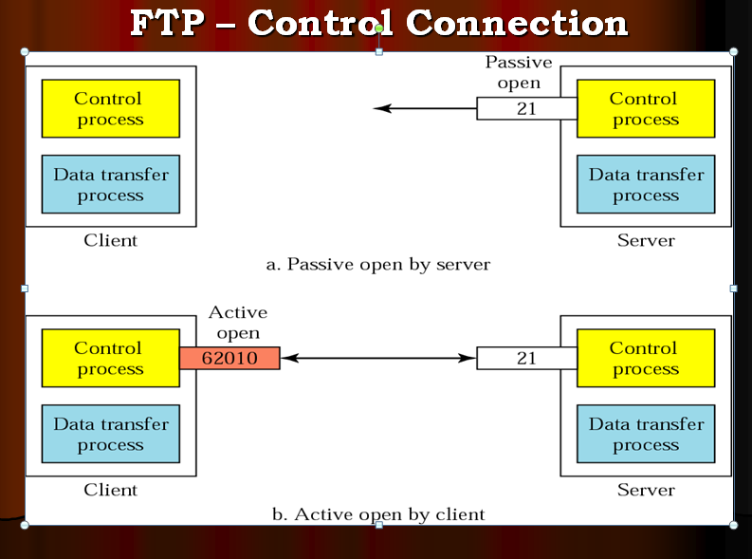

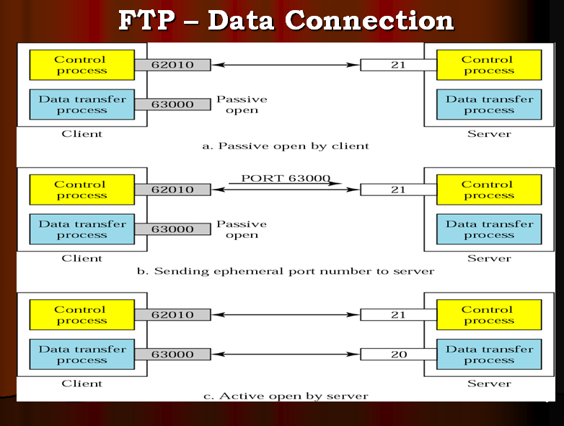

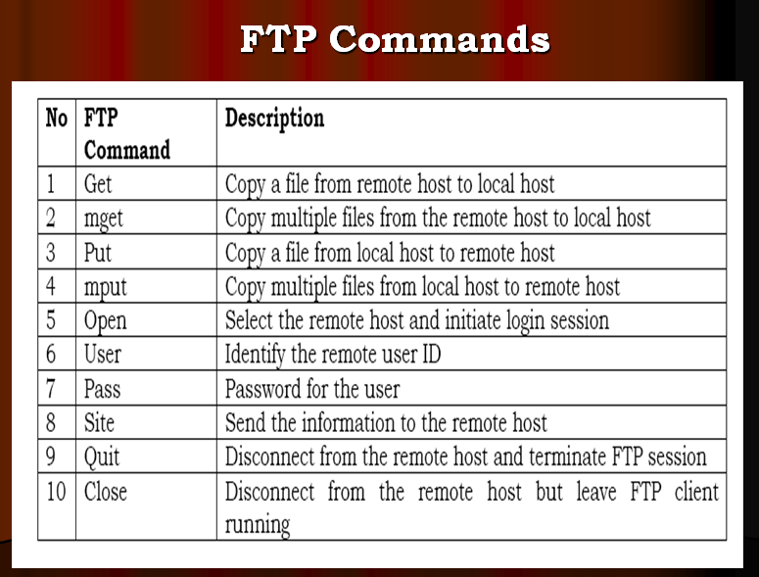

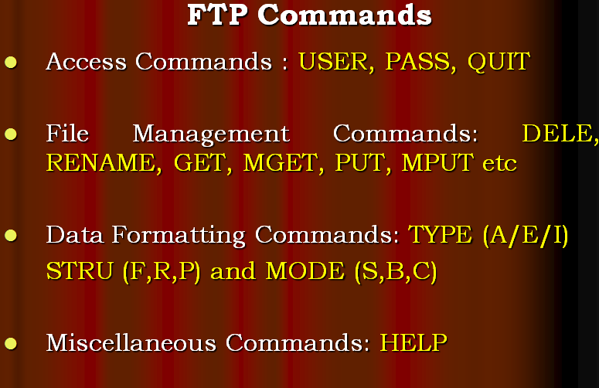

Our Practical Example :

Configuration of FTP SERVER using Packet Tracer
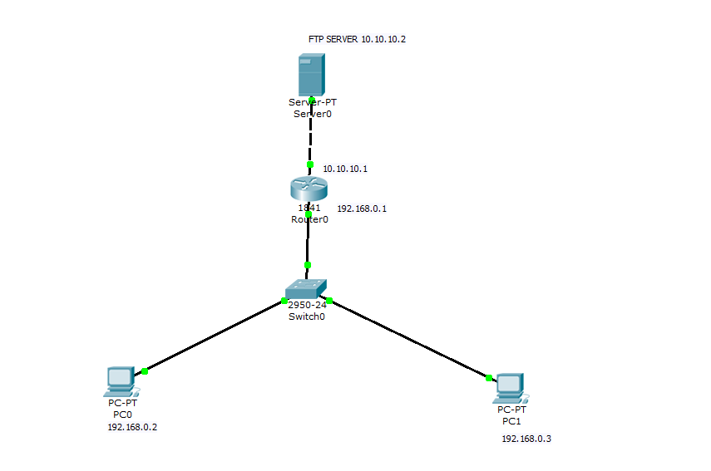

OUTPUT:

To download go to PC1
PC1>ftp 10.10.10.2
Username and password as gmw and gmw
ftp>get hi.txt
ftp>dir

Output-
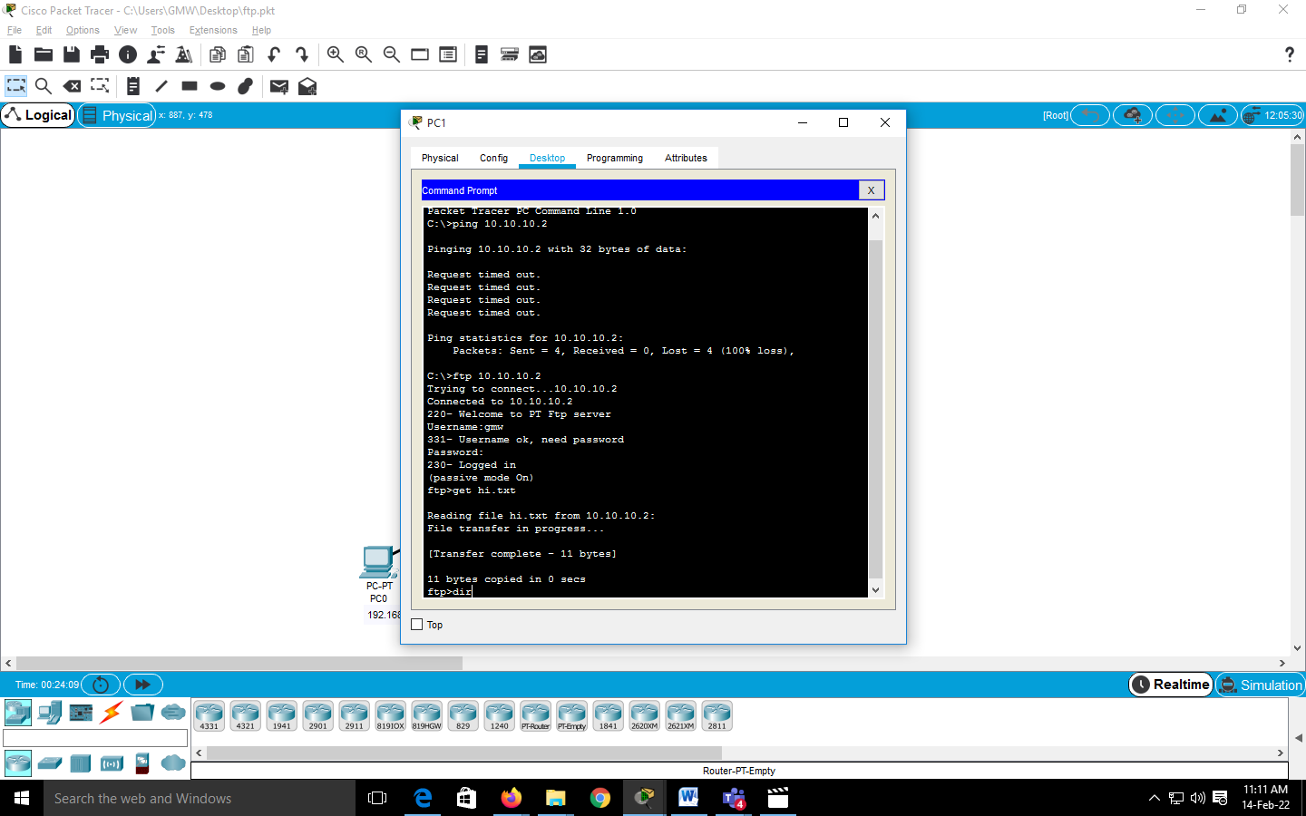

B)Web Server

- Web server
  - Specialized software that responds to client requests by providing resources
  - When users enter URL into Web browsers, they request specific documents from Web server
  - Maps URL to file on server and returns requested document to client
  - Communicates with client using HTTP
    - Protocol for transferring requests and files over the Internet
- Example of Web servers
  - Internet Information Services (IIS), Personal Web Server (PWS), Apache Web Server, Tomcat

Our Practical Example of Web server in Packet Tracer:

Configuration of Web server using Packet Tracer
1. Consider following scenario
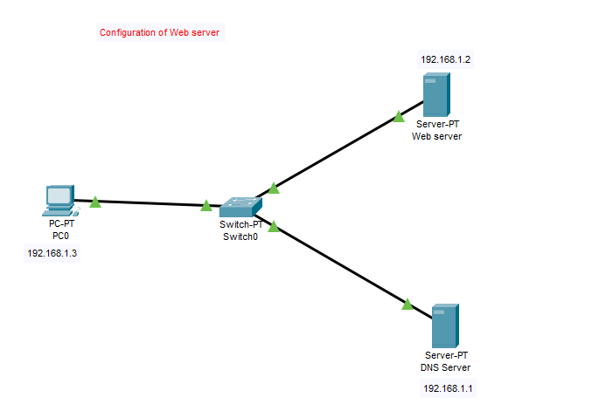

Output –
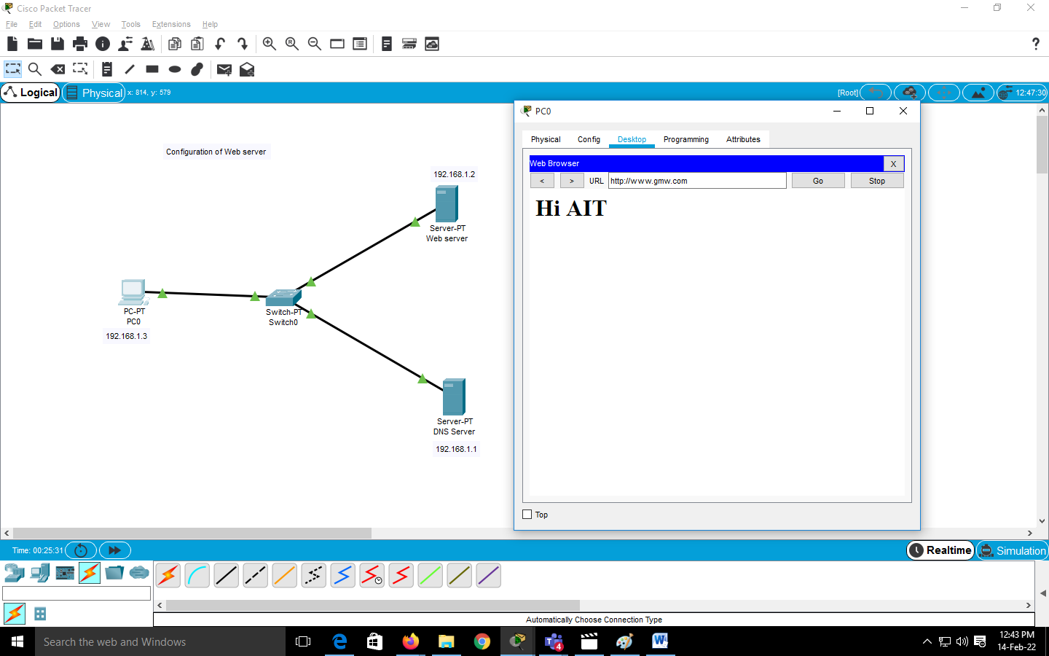
Input: Packet
Output: Upload and download of documents on FTP and Web Server.

Conclusion Students has learned the importance and use server configuration and commands.

Experiment No. 5

Title: Implement a client and a server on different computers using python. Perform the communication between these two entities by using RSA cryptosystem

Aim: To Study and implement RSA algorithm and use it in communication between the computers.

Objective: To use RSA cryptosystem in client server communication using python..

Theory :

Public Key Cryptography
Unlike symmetric key cryptography, we do not find historical use of public-key cryptography. It is a relatively new concept.Symmetric cryptography was well suited for organizations such as governments, military, and big financial corporations were involved in the classified communication.With the spread of more unsecure computer networks in last few decades, a genuine need was felt to use cryptography at larger scale. The symmetric key was found to be non-practical due to challenges it faced for key management. This gave rise to the public key cryptosystems.
The process of encryption and decryption is depicted in the following illustration −
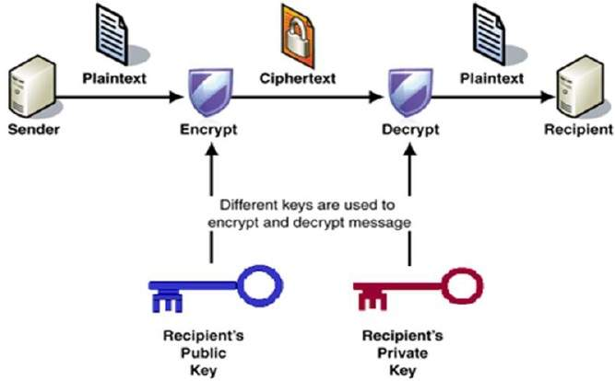
The most important properties of public key encryption scheme are −
- Different keys are used for encryption and decryption. This is a property which set this scheme different than symmetric encryption scheme.
- Each receiver possesses a unique decryption key, generally referred to as his private key.
- Receiver needs to publish an encryption key, referred to as his public key.
- Some assurance of the authenticity of a public key is needed in this scheme to avoid spoofing by adversary as the receiver. Generally, this type of cryptosystem involves trusted third party which certifies that a particular public key belongs to a specific person or entity only.
- Encryption algorithm is complex enough to prohibit attacker from deducing the plaintext from the ciphertext and the encryption (public) key.
- Though private and public keys are related mathematically, it is not be feasible to calculate the private key from the public key. In fact, intelligent part of any public-key cryptosystem is in designing a relationship between two keys.
There are three types of Public Key Encryption schemes. We discuss them in following sections −

RSA Cryptosystem

This cryptosystem is one the initial system. It remains most employed cryptosystem even today. The system was invented by three scholars Ron Rivest, Adi Shamir, and Len Adleman and hence, it is termed as RSA cryptosystem.
RSA Algorithm:

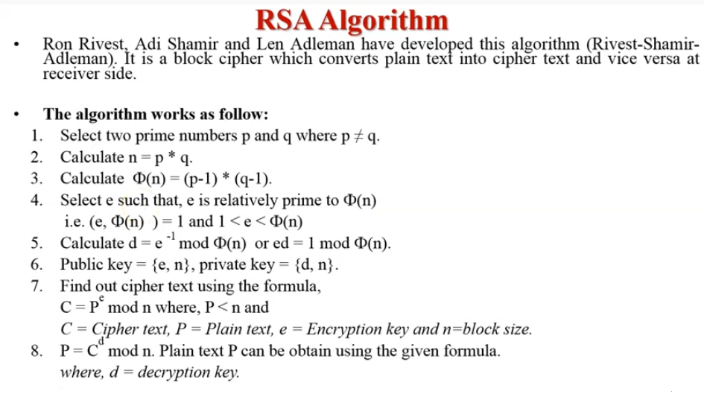

Details Explanation:
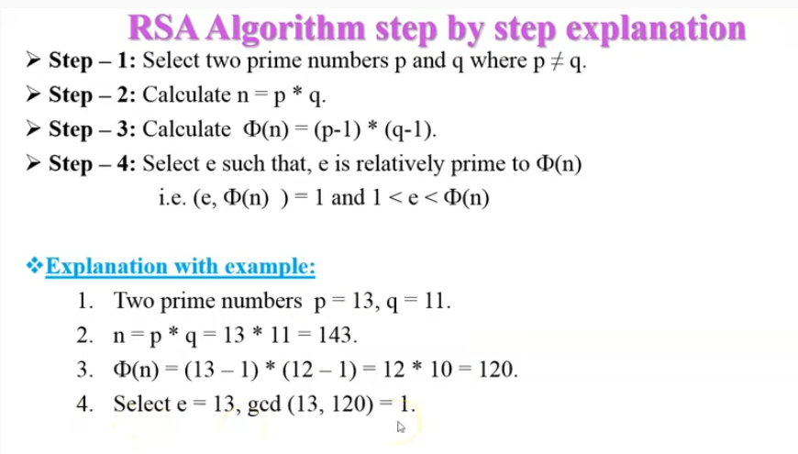
Note that GCD of (e, φ(n) ) =1.
Here note that e is the public key of this algorithm
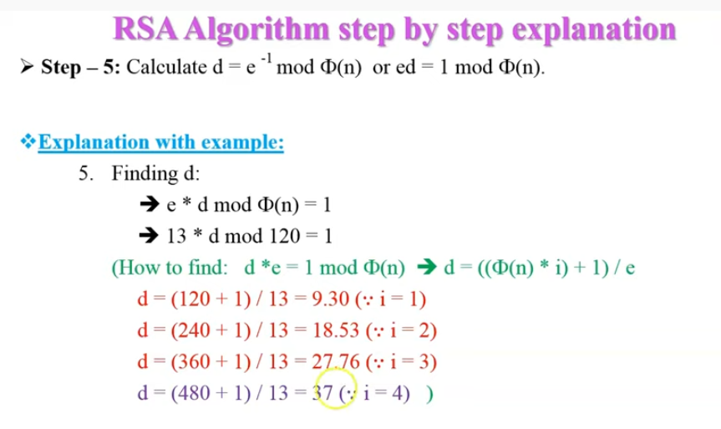
Here in this step we have to find d ( Private Key of this Algorithm).
WE have to increase i value as 1,2,…
When we get integer value for d then we have to stop, otherwise for
float value we need to Continue the calculation

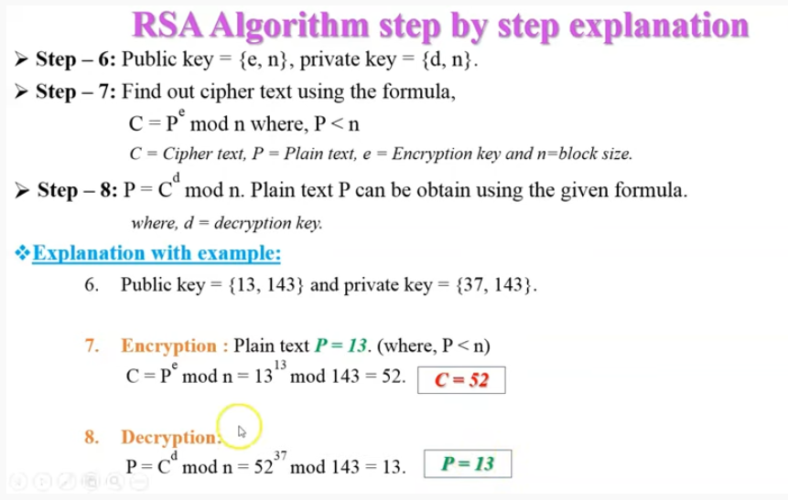
---------------------------------------------------------------------------------------------------------
.
Python code for RSA Algorithm

RSA Algorithm

try:
input = raw_input
except NameError:
pass
try:
chr = unichr
except NameError:
pass
p=int(input('Enter prime p: '))
q=int(input('Enter prime q: '))
print("Choosen primes:\np=" + str(p) + ", q=" + str(q) + "\n")
n=p*q
print("n = p * q = " + str(n) + "\n")
phi=(p-1)*(q-1)
print("Euler's function (totient) [phi(n)]: " + str(phi) + "\n")
def gcd(a, b):
while b != 0:
c = a % b
a = b
b = c
return a
def modinv(a, m):
for x in range(1, m):
if (a * x) % m == 1:
return x
return None
def coprimes(a):
l = []
for x in range(2, a):
if gcd(a, x) == 1 and modinv(x,phi) != None:
l.append(x)
for x in l:
if x == modinv(x,phi):
l.remove(x)
return l
print("Choose an e from a below coprimes array:\n")
print(str(coprimes(phi)) + "\n")
e=int(input())
d=modinv(e,phi)
print("\nYour public key is a pair of numbers (e=" + str(e) + ", n=" + str(n) + ").\n")
print("Your private key is a pair of numbers (d=" + str(d) + ", n=" + str(n) + ").\n")
def encrypt_block(m):
c = modinv(m**e, n)
if c == None: print('No modular multiplicative inverse for block ' + str(m) + '.')
return c
def decrypt_block(c):
m = modinv(c**d, n)
if m == None: print('No modular multiplicative inverse for block ' + str(c) + '.')
return m
def encrypt_string(s):
return ''.join([chr(encrypt_block(ord(x))) for x in list(s)])
def decrypt_string(s):
return ''.join([chr(decrypt_block(ord(x))) for x in list(s)])
s = input("Enter a message to encrypt: ")
print("\nPlain message: " + s + "\n")
enc = encrypt_string(s)
print("Encrypted message: " + enc + "\n")
dec = decrypt_string(enc)
print("Decrypted message: " + dec + "\n")

Output:
C:\Users\ML-174\PycharmProjects\pythonProject7\venv\Scripts\python.exe C:/Users/ML-174/PycharmProjects/pythonProject7/main.py
Enter prime p: 11
Enter prime q: 13
Choosen primes:
p=11, q=13

n = p * q = 143

Euler's function (totient) [phi(n)]: 120

Choose an e from a below coprimes array:

[7, 13, 17, 23, 31, 37, 43, 47, 53, 61, 67, 73, 77, 83, 91, 97, 103, 107, 113]

13

Your public key is a pair of numbers (e=13, n=143).

Your private key is a pair of numbers (d=37, n=143).

Enter a message to encrypt: 12

Plain message: 12

Encrypted message: E

Decrypted message: 12

Process finished with exit code 0

Pythom code for clent Server Socket:

Server.py

import socket
# take the server name and port name
# create a socket at server side
# using TCP / IP protocol
s = socket.socket(socket.AF_INET,socket.SOCK_STREAM)
# bind the socket with server
# and port number
s.bind((socket.gethostname(), 1234))
# allow maximum 1 connection to
# the socket
s.listen(5)
while True:
clientsocket,address=s.accept()
print(f"connection from {address} has been establsihed")
val = input("Enter your value: ")
clientsocket.send(bytes(val,"utf-8"))
clientsocket.close()

Client.py
import socket
# take the server name and port name
# create a socket at client side
# using TCP / IP protocol
s = socket.socket(socket.AF_INET,socket.SOCK_STREAM)
# connect it to server and port
# number on local computer.
s.connect((socket.gethostname(), 1234))
# receive message string from
# server, at a time 1024 B
msg = s.recv(1024)
print(msg.decode("utf-8"))
# msg = s.recv(1024)
# disconnect the client
s.close()

Output:
Server.py
C:\Users\ML-174\PycharmProjects\pythonProject2\venv\Scripts\python.exe C:/Users/ML-174/PycharmProjects/pythonProject2/Server.py
connection from ('192.168.100.70', 64151) has been establsihed
Enter your value: 12
Output
Client.py
C:\Users\ML-174\PycharmProjects\pythonProject2\venv\Scripts\python.exe C:/Users/ML-174/PycharmProjects/pythonProject2/clent.py
12

Process finished with exit code

Input: Plaintext
Output: Cipher Text sent to other PC and obtained the plaintext back.

Conclusion:
Learned the RSA Cryptosystem.

Experiment No. 6

Title : Implement a client and a server on different computers using python. Perform the authentication of sender between these two entities by using RSA digital signature cryptosystem.

Aim : To implement RSA digital Cryptosystem in python on two different machine act as client an server.

Objective : To understand authentication of senders using RSA digital signature cryptosystem.

Theory :

Digital Signature : In simple words, digital signatures are used to verify the authenticity of the message sent electronically. RSA : It is the most popular asymmetric cryptographic algorithm. It is primarily used for encrypting message s but can also be used for performing digital signature over a message.
RSA idea is also used for signing and verifying a message it is called RSA digital signature scheme. Sender uses her own private key to sign the document and the receiver uses the sender's public key to verify it. ... If the result is two true the message is accepted

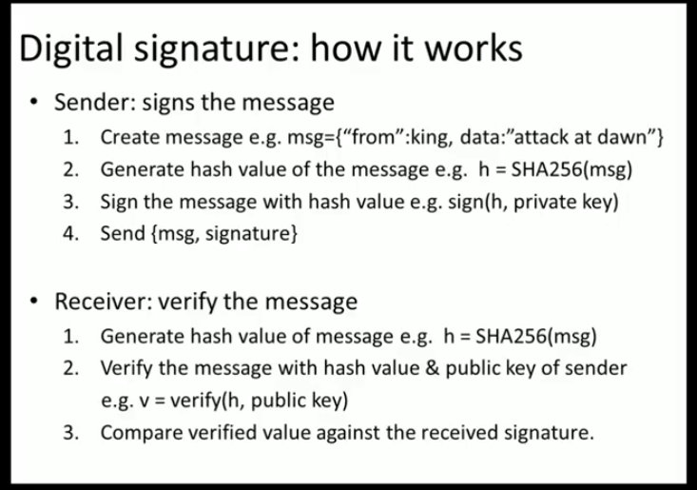

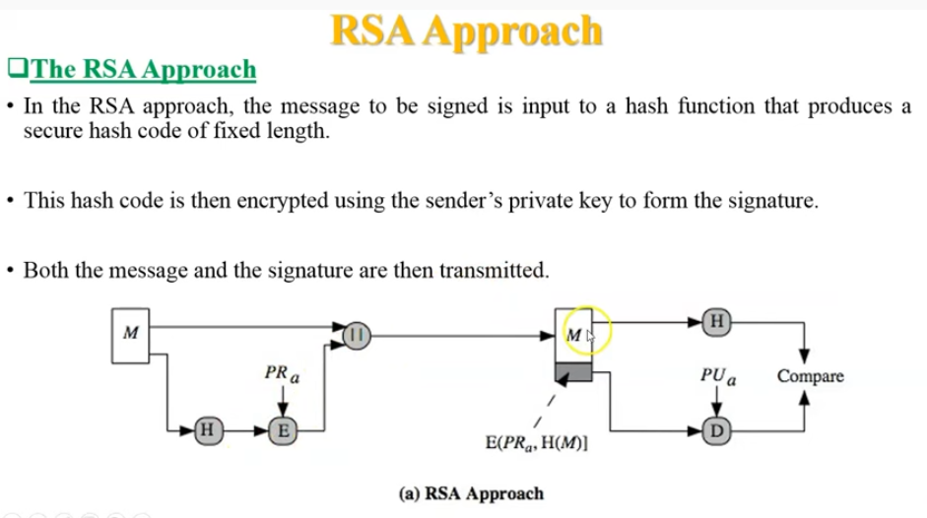

Implemetation1 of RSA Digital Signature scheme using Python:
RSA algorithm is an asymmetric cryptography algorithm. Asymmetric actually means that it works on two different keys i.e. Public Key and Private Key. As the name describes that the Public Key is given to everyone and the Private key is kept private.
An example of asymmetric cryptography :
- A client (for example browser) sends its public key to the server and requests for some data.
- The server encrypts the data using the client’s public key and sends the encrypted data.
- Client receives this data and decrypts it.
Since this is asymmetric, nobody else except the browser can decrypt the data even if a third party has the public key of browser.
Digital signatures are used to verify the authenticity of the message sent electronically. A digital signature algorithm uses a public key system. The intended transmitter signs his/her message with his/her private key and the intended receiver verifies it with the transmitter’s public key. A digital signature can provide message authentication, message integrity and non-repudiation services.

Algorithm
RSA Key Generation:
- Choose two large prime numbers p and q
- Calculate n=p*q
- Select public key e such that it is not a factor of (p-1)*(q-1)
- Select private key d such that the following equation is true (d*e)mod(p-1)(q-1)=1 or d is inverse of E in modulo (p-1)*(q-1)
RSA Digital Signature Scheme: In RSA, d is private; e and n are public.
- Alice creates her digital signature using S=M^d mod n where M is the message
- Alice sends Message M and Signature S to Bob
- Bob computes M1=S^e mod n
- If M1=M then Bob accepts the data sent by Alice.

Python Code (Implementation1):

# Function to find gcd
# of two numbers
def euclid(m, n):

if n == 0:
return m
else:
r = m % n
return euclid(n, r)

# Program to find
# Multiplicative inverse
def exteuclid(a, b):

r1 = a
r2 = b
s1 = int(1)
s2 = int(0)
t1 = int(0)
t2 = int(1)

while r2 > 0:

q = r1//r2
r = r1-q * r2
r1 = r2
r2 = r
s = s1-q * s2
s1 = s2
s2 = s
t = t1-q * t2
t1 = t2
t2 = t

if t1 < 0:
t1 = t1 % a

return (r1, t1)

# Enter two large prime
# numbers p and q
p = 823
q = 953
n = p * q
Pn = (p-1)*(q-1)

# Generate encryption key
# in range 1<e<Pn
key = []

for i in range(2, Pn):

gcd = euclid(Pn, i)

if gcd == 1:
key.append(i)

# Select an encryption key
# from the above list
e = int(313)

# Obtain inverse of
# encryption key in Z_Pn
r, d = exteuclid(Pn, e)
if r == 1:
d = int(d)
print("decryption key is: ", d)

else:
print("Multiplicative inverse for\
the given encryption key does not \
exist. Choose a different encryption key ")

# Enter the message to be sent
M = 19070

# Signature is created by Alice
S = (M**d) % n

# Alice sends M and S both to Bob
# Bob generates message M1 using the
# signature S, Alice's public key e
# and product n.
M1 = (S**e) % n

# If M = M1 only then Bob accepts
# the message sent by Alice.

if M == M1:
print("As M = M1, Accept the\
message sent by Alice")
else:
print("As M not equal to M1,\
Do not accept the message\
sent by Alice ")

Output:
decryption key is: 160009
As M = M1, Accept the message sent by Alice

Input: Message

Output: Digital Signature verification

Conclusion:
understood the authentication using RSA Digital signature scheme.

Experiment No. 7

Title: Implement a client and a server on different computers using python. Perform the encryption of message of sender between these two entities by using DES Algorithm and use Diffie Hellman method for exchange of keys.

Aim: Implement encryption of message of sender between these two entities by using DES Algorithm and use Diffie Hellman method for exchange of keys in python.

Objective: To learn DES Algorithm and use Diffie Hellman method for exchange of keys.

Theory :

Data encryption standard (DES)
Data encryption standard (DES) has been found vulnerable against very powerful attacks and therefore, the popularity of DES has been found slightly on the decline.
DES is a block cipher and encrypts data in blocks of size of 64 bits each, which means 64 bits of plain text goes as the input to DES, which produces 64 bits of ciphertext. The same algorithm and key are used for encryption and decryption, with minor differences. The key length is 56 bits. The basic idea is shown in the figure.
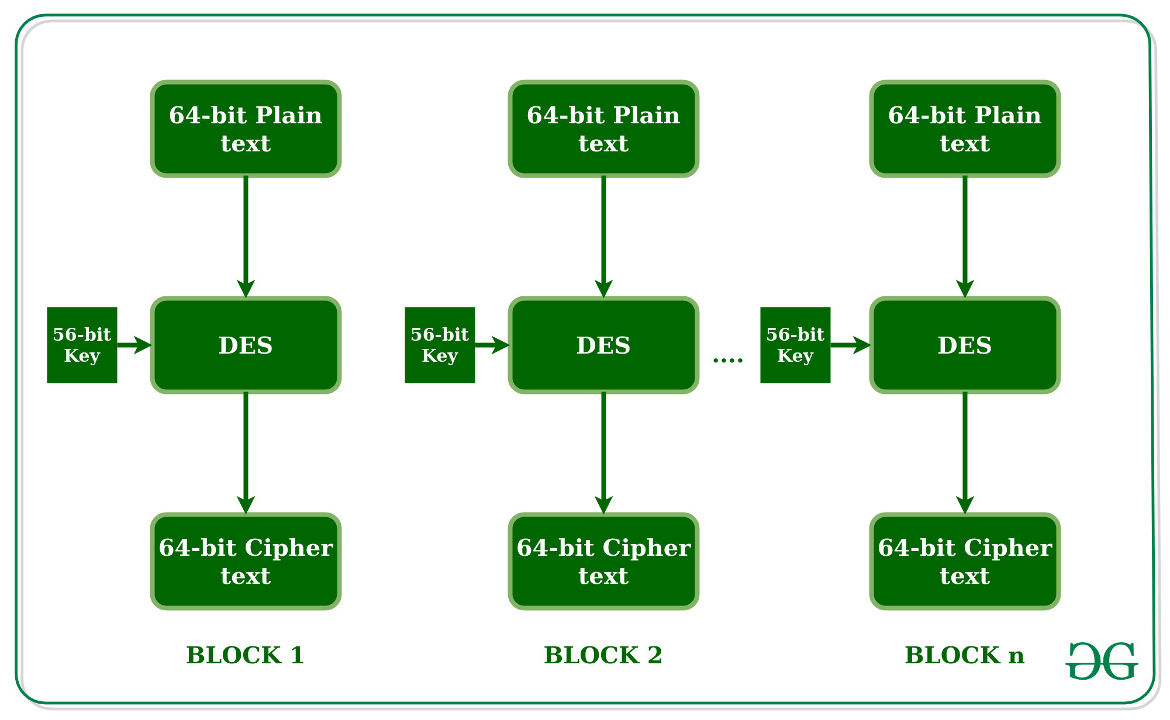
We have mentioned that DES uses a 56-bit key. Actually, the initial key consists of 64 bits. However, before the DES process even starts, every 8th bit of the key is discarded to produce a 56-bit key. That is bit positions 8, 16, 24, 32, 40, 48, 56, and 64 are discarded.
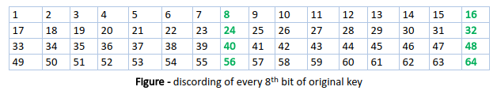
Thus, the discarding of every 8th bit of the key produces a 56-bit key from the original 64-bit key.
DES is based on the two fundamental attributes of cryptography: substitution (also called confusion) and transposition (also called diffusion). DES consists of 16 steps, each of which is called a round. Each round performs the steps of substitution and transposition. Let us now discuss the broad-level steps in DES.
- In the first step, the 64-bit plain text block is handed over to an initial Permutation (IP) function.
- The initial permutation is performed on plain text.
- Next, the initial permutation (IP) produces two halves of the permuted block; says Left Plain Text (LPT) and Right Plain Text (RPT).
- Now each LPT and RPT go through 16 rounds of the encryption process.
- In the end, LPT and RPT are rejoined and a Final Permutation (FP) is performed on the combined block
- The result of this process produces 64-bit ciphertext.
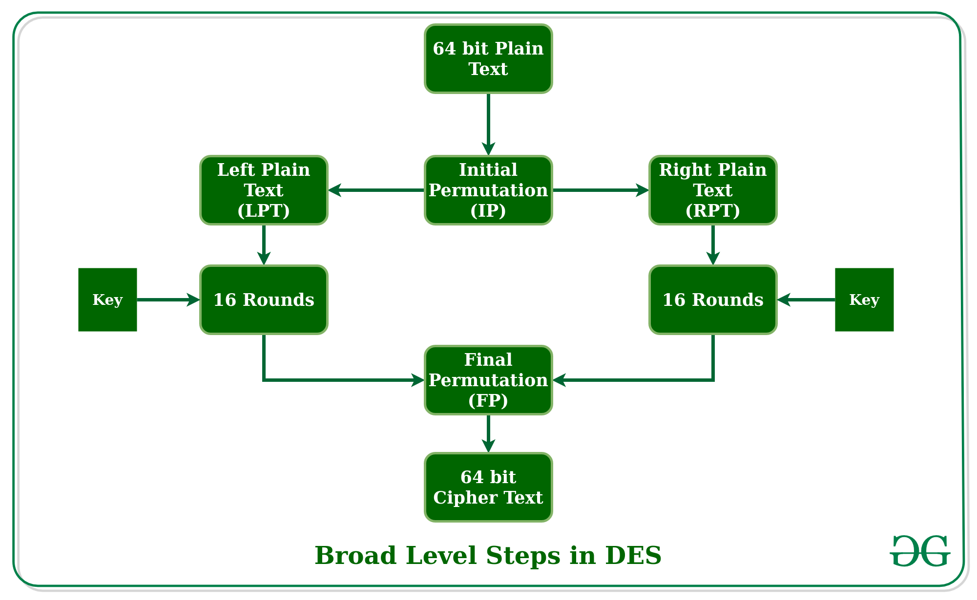
Initial Permutation (IP) –
As we have noted, the initial permutation (IP) happens only once and it happens before the first round. It suggests how the transposition in IP should proceed, as shown in the figure.
For example, it says that the IP replaces the first bit of the original plain text block with the 58th bit of the original plain text, the second bit with the 50th bit of the original plain text block, and so on.
This is nothing but jugglery of bit positions of the original plain text block. the same rule applies to all the other bit positions shown in the figure.
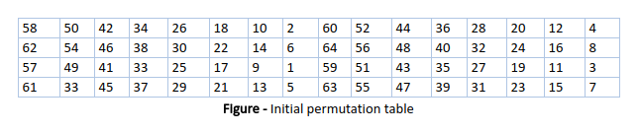
As we have noted after IP is done, the resulting 64-bit permuted text block is divided into two half blocks. Each half-block consists of 32 bits, and each of the 16 rounds, in turn, consists of the broad level steps outlined in the figure.
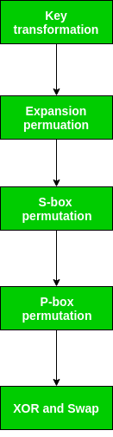
Step-1: Key transformation –
We have noted initial 64-bit key is transformed into a 56-bit key by discarding every 8th bit of the initial key. Thus, for each a 56-bit key is available. From this 56-bit key, a different 48-bit Sub Key is generated during each round using a process called key transformation. For this, the 56-bit key is divided into two halves, each of 28 bits. These halves are circularly shifted left by one or two positions, depending on the round.
For example, if the round numbers 1, 2, 9, or 16 the shift is done by only position for other rounds, the circular shift is done by two positions. The number of key bits shifted per round is shown in the figure.
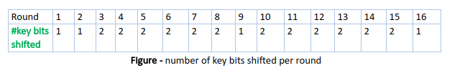
After an appropriate shift, 48 of the 56 bits are selected. for selecting 48 of the 56 bits the table is shown in the figure given below. For instance, after the shift, bit number 14 moves on the first position, bit number 17 moves on the second position, and so on. If we observe the table carefully, we will realize that it contains only 48-bit positions. Bit number 18 is discarded (we will not find it in the table), like 7 others, to reduce a 56-bit key to a 48-bit key. Since the key transformation process involves permutation as well as a selection of a 48-bit subset of the original 56-bit key it is called Compression Permutation.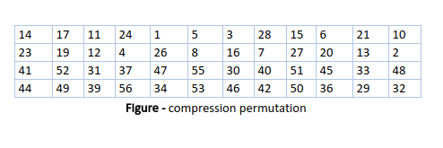
Because of this compression permutation technique, a different subset of key bits is used in each round. That makes DES not easy to crack.
Step-2: Expansion Permutation –
Recall that after initial permutation, we had two 32-bit plain text areas called Left Plain Text(LPT) and Right Plain Text(RPT). During the expansion permutation, the RPT is expanded from 32 bits to 48 bits. Bits are permuted as well hence called expansion permutation. This happens as the 32-bit RPT is divided into 8 blocks, with each block consisting of 4 bits. Then, each 4-bit block of the previous step is then expanded to a corresponding 6-bit block, i.e., per 4-bit block, 2 more bits are added.
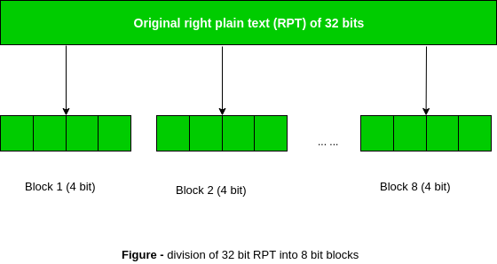
This process results in expansion as well as a permutation of the input bit while creating output. The key transformation process compresses the 56-bit key to 48 bits. Then the expansion permutation process expands the 32-bit RPT to 48-bits. Now the 48-bit key is XOR with 48-bit RPT and the resulting output is given to the next step, which is the S-Box substitution.

Python code for DES:

# Hexadecimal to binary conversion
def hex2bin(s):
mp = {'0' : "0000",
'1' : "0001",
'2' : "0010",
'3' : "0011",
'4' : "0100",
'5' : "0101",
'6' : "0110",
'7' : "0111",
'8' : "1000",
'9' : "1001",
'A' : "1010",
'B' : "1011",
'C' : "1100",
'D' : "1101",
'E' : "1110",
'F' : "1111" }
bin = ""
for i in range(len(s)):
bin = bin + mp[s[i]]
return bin

# Binary to hexadecimal conversion
def bin2hex(s):
mp = {"0000" : '0',
"0001" : '1',
"0010" : '2',
"0011" : '3',
"0100" : '4',
"0101" : '5',
"0110" : '6',
"0111" : '7',
"1000" : '8',
"1001" : '9',
"1010" : 'A',
"1011" : 'B',
"1100" : 'C',
"1101" : 'D',
"1110" : 'E',
"1111" : 'F' }
hex = ""
for i in range(0,len(s),4):
ch = ""
ch = ch + s[i]
ch = ch + s[i + 1]
ch = ch + s[i + 2]
ch = ch + s[i + 3]
hex = hex + mp[ch]

return hex

# Binary to decimal conversion
def bin2dec(binary):

binary1 = binary
decimal, i, n = 0, 0, 0
while(binary != 0):
dec = binary % 10
decimal = decimal + dec * pow(2, i)
binary = binary//10
i += 1
return decimal

# Decimal to binary conversion
def dec2bin(num):
res = bin(num).replace("0b", "")
if(len(res)%4 != 0):
div = len(res) / 4
div = int(div)
counter =(4 * (div + 1)) - len(res)
for i in range(0, counter):
res = '0' + res
return res

# Permute function to rearrange the bits
def permute(k, arr, n):
permutation = ""
for i in range(0, n):
permutation = permutation + k[arr[i] - 1]
return permutation

# shifting the bits towards left by nth shifts
def shift_left(k, nth_shifts):
s = ""
for i in range(nth_shifts):
for j in range(1,len(k)):
s = s + k[j]
s = s + k[0]
k = s
s = ""
return k

# calculating xow of two strings of binary number a and b
def xor(a, b):
ans = ""
for i in range(len(a)):
if a[i] == b[i]:
ans = ans + "0"
else:
ans = ans + "1"
return ans

# Table of Position of 64 bits at initial level: Initial Permutation Table
initial_perm = [58, 50, 42, 34, 26, 18, 10, 2,
60, 52, 44, 36, 28, 20, 12, 4,
62, 54, 46, 38, 30, 22, 14, 6,
64, 56, 48, 40, 32, 24, 16, 8,
57, 49, 41, 33, 25, 17, 9, 1,
59, 51, 43, 35, 27, 19, 11, 3,
61, 53, 45, 37, 29, 21, 13, 5,
63, 55, 47, 39, 31, 23, 15, 7]

# Expansion D-box Table
exp_d = [32, 1 , 2 , 3 , 4 , 5 , 4 , 5,
6 , 7 , 8 , 9 , 8 , 9 , 10, 11,
12, 13, 12, 13, 14, 15, 16, 17,
16, 17, 18, 19, 20, 21, 20, 21,
22, 23, 24, 25, 24, 25, 26, 27,
28, 29, 28, 29, 30, 31, 32, 1 ]

# Straight Permutation Table
per = [ 16, 7, 20, 21,
29, 12, 28, 17,
1, 15, 23, 26,
5, 18, 31, 10,
2, 8, 24, 14,
32, 27, 3, 9,
19, 13, 30, 6,
22, 11, 4, 25 ]

# S-box Table
sbox = [[[14, 4, 13, 1, 2, 15, 11, 8, 3, 10, 6, 12, 5, 9, 0, 7],
[ 0, 15, 7, 4, 14, 2, 13, 1, 10, 6, 12, 11, 9, 5, 3, 8],
[ 4, 1, 14, 8, 13, 6, 2, 11, 15, 12, 9, 7, 3, 10, 5, 0],
[15, 12, 8, 2, 4, 9, 1, 7, 5, 11, 3, 14, 10, 0, 6, 13 ]],

[[15, 1, 8, 14, 6, 11, 3, 4, 9, 7, 2, 13, 12, 0, 5, 10],
[3, 13, 4, 7, 15, 2, 8, 14, 12, 0, 1, 10, 6, 9, 11, 5],
[0, 14, 7, 11, 10, 4, 13, 1, 5, 8, 12, 6, 9, 3, 2, 15],
[13, 8, 10, 1, 3, 15, 4, 2, 11, 6, 7, 12, 0, 5, 14, 9 ]],

[ [10, 0, 9, 14, 6, 3, 15, 5, 1, 13, 12, 7, 11, 4, 2, 8],
[13, 7, 0, 9, 3, 4, 6, 10, 2, 8, 5, 14, 12, 11, 15, 1],
[13, 6, 4, 9, 8, 15, 3, 0, 11, 1, 2, 12, 5, 10, 14, 7],
[1, 10, 13, 0, 6, 9, 8, 7, 4, 15, 14, 3, 11, 5, 2, 12 ]],

[ [7, 13, 14, 3, 0, 6, 9, 10, 1, 2, 8, 5, 11, 12, 4, 15],
[13, 8, 11, 5, 6, 15, 0, 3, 4, 7, 2, 12, 1, 10, 14, 9],
[10, 6, 9, 0, 12, 11, 7, 13, 15, 1, 3, 14, 5, 2, 8, 4],
[3, 15, 0, 6, 10, 1, 13, 8, 9, 4, 5, 11, 12, 7, 2, 14] ],

[ [2, 12, 4, 1, 7, 10, 11, 6, 8, 5, 3, 15, 13, 0, 14, 9],
[14, 11, 2, 12, 4, 7, 13, 1, 5, 0, 15, 10, 3, 9, 8, 6],
[4, 2, 1, 11, 10, 13, 7, 8, 15, 9, 12, 5, 6, 3, 0, 14],
[11, 8, 12, 7, 1, 14, 2, 13, 6, 15, 0, 9, 10, 4, 5, 3 ]],

[ [12, 1, 10, 15, 9, 2, 6, 8, 0, 13, 3, 4, 14, 7, 5, 11],
[10, 15, 4, 2, 7, 12, 9, 5, 6, 1, 13, 14, 0, 11, 3, 8],
[9, 14, 15, 5, 2, 8, 12, 3, 7, 0, 4, 10, 1, 13, 11, 6],
[4, 3, 2, 12, 9, 5, 15, 10, 11, 14, 1, 7, 6, 0, 8, 13] ],

[ [4, 11, 2, 14, 15, 0, 8, 13, 3, 12, 9, 7, 5, 10, 6, 1],
[13, 0, 11, 7, 4, 9, 1, 10, 14, 3, 5, 12, 2, 15, 8, 6],
[1, 4, 11, 13, 12, 3, 7, 14, 10, 15, 6, 8, 0, 5, 9, 2],
[6, 11, 13, 8, 1, 4, 10, 7, 9, 5, 0, 15, 14, 2, 3, 12] ],

[ [13, 2, 8, 4, 6, 15, 11, 1, 10, 9, 3, 14, 5, 0, 12, 7],
[1, 15, 13, 8, 10, 3, 7, 4, 12, 5, 6, 11, 0, 14, 9, 2],
[7, 11, 4, 1, 9, 12, 14, 2, 0, 6, 10, 13, 15, 3, 5, 8],
[2, 1, 14, 7, 4, 10, 8, 13, 15, 12, 9, 0, 3, 5, 6, 11] ] ]

# Final Permutation Table
final_perm = [ 40, 8, 48, 16, 56, 24, 64, 32,
39, 7, 47, 15, 55, 23, 63, 31,
38, 6, 46, 14, 54, 22, 62, 30,
37, 5, 45, 13, 53, 21, 61, 29,
36, 4, 44, 12, 52, 20, 60, 28,
35, 3, 43, 11, 51, 19, 59, 27,
34, 2, 42, 10, 50, 18, 58, 26,
33, 1, 41, 9, 49, 17, 57, 25 ]

def encrypt(pt, rkb, rk):
pt = hex2bin(pt)

# Initial Permutation
pt = permute(pt, initial_perm, 64)
print("After initial permutation", bin2hex(pt))

# Splitting
left = pt[0:32]
right = pt[32:64]
for i in range(0, 16):
# Expansion D-box: Expanding the 32 bits data into 48 bits
right_expanded = permute(right, exp_d, 48)

# XOR RoundKey[i] and right_expanded
xor_x = xor(right_expanded, rkb[i])

# S-boxex: substituting the value from s-box table by calculating row and column
sbox_str = ""
for j in range(0, 8):
row = bin2dec(int(xor_x[j * 6] + xor_x[j * 6 + 5]))
col = bin2dec(int(xor_x[j * 6 + 1] + xor_x[j * 6 + 2] + xor_x[j * 6 + 3] + xor_x[j * 6 + 4]))
val = sbox[j][row][col]
sbox_str = sbox_str + dec2bin(val)

# Straight D-box: After substituting rearranging the bits
sbox_str = permute(sbox_str, per, 32)

# XOR left and sbox_str
result = xor(left, sbox_str)
left = result

# Swapper
if(i != 15):
left, right = right, left
print("Round ", i + 1, " ", bin2hex(left), " ", bin2hex(right), " ", rk[i])

# Combination
combine = left + right

# Final permutation: final rearranging of bits to get cipher text
cipher_text = permute(combine, final_perm, 64)
return cipher_text

pt = "123456ABCD132536"
key = "AABB09182736CCDD"

# Key generation
# --hex to binary
key = hex2bin(key)

# --parity bit drop table
keyp = [57, 49, 41, 33, 25, 17, 9,
1, 58, 50, 42, 34, 26, 18,
10, 2, 59, 51, 43, 35, 27,
19, 11, 3, 60, 52, 44, 36,
63, 55, 47, 39, 31, 23, 15,
7, 62, 54, 46, 38, 30, 22,
14, 6, 61, 53, 45, 37, 29,
21, 13, 5, 28, 20, 12, 4 ]

# getting 56 bit key from 64 bit using the parity bits
key = permute(key, keyp, 56)

# Number of bit shifts
shift_table = [1, 1, 2, 2,
2, 2, 2, 2,
1, 2, 2, 2,
2, 2, 2, 1 ]

# Key- Compression Table : Compression of key from 56 bits to 48 bits
key_comp = [14, 17, 11, 24, 1, 5,
3, 28, 15, 6, 21, 10,
23, 19, 12, 4, 26, 8,
16, 7, 27, 20, 13, 2,
41, 52, 31, 37, 47, 55,
30, 40, 51, 45, 33, 48,
44, 49, 39, 56, 34, 53,
46, 42, 50, 36, 29, 32 ]

# Splitting
left = key[0:28] # rkb for RoundKeys in binary
right = key[28:56] # rk for RoundKeys in hexadecimal

rkb = []
rk = []
for i in range(0, 16):
# Shifting the bits by nth shifts by checking from shift table
left = shift_left(left, shift_table[i])
right = shift_left(right, shift_table[i])

# Combination of left and right string
combine_str = left + right

# Compression of key from 56 to 48 bits
round_key = permute(combine_str, key_comp, 48)

rkb.append(round_key)
rk.append(bin2hex(round_key))

print("Encryption")
cipher_text = bin2hex(encrypt(pt, rkb, rk))
print("Cipher Text : ",cipher_text)

print("Decryption")
rkb_rev = rkb[::-1]
rk_rev = rk[::-1]
text = bin2hex(encrypt(cipher_text, rkb_rev, rk_rev))
print("Plain Text : ",text)

Output:
Encryption:

After initial permutation: 14A7D67818CA18AD
After splitting: L0=14A7D678 R0=18CA18AD

Round 1 18CA18AD 5A78E394 194CD072DE8C
Round 2 5A78E394 4A1210F6 4568581ABCCE
Round 3 4A1210F6 B8089591 06EDA4ACF5B5
Round 4 B8089591 236779C2 DA2D032B6EE3
Round 5 236779C2 A15A4B87 69A629FEC913
Round 6 A15A4B87 2E8F9C65 C1948E87475E
Round 7 2E8F9C65 A9FC20A3 708AD2DDB3C0
Round 8 A9FC20A3 308BEE97 34F822F0C66D
Round 9 308BEE97 10AF9D37 84BB4473DCCC
Round 10 10AF9D37 6CA6CB20 02765708B5BF
Round 11 6CA6CB20 FF3C485F 6D5560AF7CA5
Round 12 FF3C485F 22A5963B C2C1E96A4BF3
Round 13 22A5963B 387CCDAA 99C31397C91F
Round 14 387CCDAA BD2DD2AB 251B8BC717D0
Round 15 BD2DD2AB CF26B472 3330C5D9A36D
Round 16 19BA9212 CF26B472 181C5D75C66D

Cipher Text: C0B7A8D05F3A829C

Decryption

After initial permutation: 19BA9212CF26B472
After splitting: L0=19BA9212 R0=CF26B472

Round 1 CF26B472 BD2DD2AB 181C5D75C66D
Round 2 BD2DD2AB 387CCDAA 3330C5D9A36D
Round 3 387CCDAA 22A5963B 251B8BC717D0
Round 4 22A5963B FF3C485F 99C31397C91F
Round 5 FF3C485F 6CA6CB20 C2C1E96A4BF3
Round 6 6CA6CB20 10AF9D37 6D5560AF7CA5
Round 7 10AF9D37 308BEE97 02765708B5BF
Round 8 308BEE97 A9FC20A3 84BB4473DCCC
Round 9 A9FC20A3 2E8F9C65 34F822F0C66D
Round 10 2E8F9C65 A15A4B87 708AD2DDB3C0
Round 11 A15A4B87 236779C2 C1948E87475E
Round 12 236779C2 B8089591 69A629FEC913
Round 13 B8089591 4A1210F6 DA2D032B6EE3
Round 14 4A1210F6 5A78E394 06EDA4ACF5B5
Round 15 5A78E394 18CA18AD 4568581ABCCE
Round 16 14A7D678 18CA18AD 194CD072DE8C

Plain Text: 123456ABCD132536

Implementation of Diffie-Hellman Algorithm
Diffie-Hellman algorithm
The Diffie-Hellman algorithm is being used to establish a shared secret that can be used for secret communications while exchanging data over a public network using the elliptic curve to generate points and get the secret key using the parameters.
- For the sake of simplicity and practical implementation of the algorithm, we will consider only 4 variables, one prime P and G (a primitive root of P) and two private values a and b.
- P and G are both publicly available numbers. Users (say Alice and Bob) pick private values a and b and they generate a key and exchange it publicly. The opposite person receives the key and that generates a secret key, after which they have the same secret key to encrypt.
Step by Step Explanation
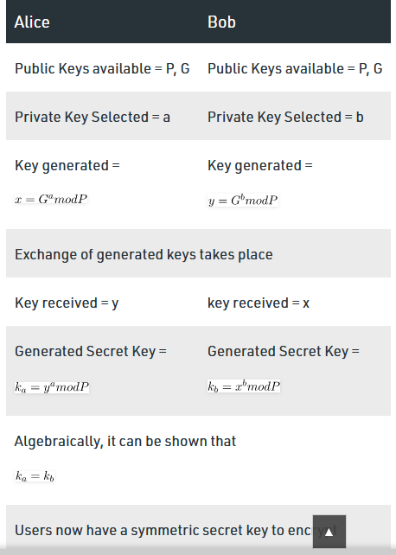

Example:
Step 1: Alice and Bob get public numbers P = 23, G = 9

Step 2: Alice selected a private key a = 4 and
Bob selected a private key b = 3

Step 3: Alice and Bob compute public values
Alice: x =(9^4 mod 23) = (6561 mod 23) = 6
Bob: y = (9^3 mod 23) = (729 mod 23) = 16

Step 4: Alice and Bob exchange public numbers

Step 5: Alice receives public key y =16 and
Bob receives public key x = 6

Step 6: Alice and Bob compute symmetric keys
Alice: ka = y^a mod p = 65536 mod 23 = 9
Bob: kb = x^b mod p = 216 mod 23 = 9

Step 7: 9 is the shared secret.
Implementation:
from random import randint

if __name__ == '__main__':

# Both the persons will be agreed upon the
# public keys G and P
# A prime number P is taken
P = 23

# A primitive root for P, G is taken
G = 9

print('The Value of P is :%d'%(P))
print('The Value of G is :%d'%(G))

# Alice will choose the private key a
a = 4
print('The Private Key a for Alice is :%d'%(a))

# gets the generated key
x = int(pow(G,a,P))

# Bob will choose the private key b
b = 3
print('The Private Key b for Bob is :%d'%(b))

# gets the generated key
y = int(pow(G,b,P))

# Secret key for Alice
ka = int(pow(y,a,P))

# Secret key for Bob
kb = int(pow(x,b,P))

print('Secret key for the Alice is : %d'%(ka))
print('Secret Key for the Bob is : %d'%(kb))
Output:
The value of P : 23
The value of G : 9

The private key a for Alice : 4
The private key b for Bob : 3

Secret key for the Alice is : 9
Secret Key for the Bob is : 9

Conclusion: Performed the encryption of message of sender between client and sender entities by using DES Algorithm and use Diffie Hellman method for exchange of keys.

Experiment No. 8

Title: Use the snort intrusion detection package to analyze traffic and create a signature to identify problem traffic.

Aim:. To study and use the snort intrusion detection package to analyze traffic and create a signature to identify problem traffic.

Objective: To learn importance of snort intrusion detection package to analyze traffic and create a signature to identify problem traffic..

Theory:

IDS/IPS - Basic Concepts
Intrusion Prevention System (IPS) - ACTIVE monitoring of activity looking for anomalies and alerting/notifiying AND taking action when they are found.
Intrusion Detection System (IDS) - PASSIVE monitoring of activity looking for anomalies and alerting/notifying when they are found.
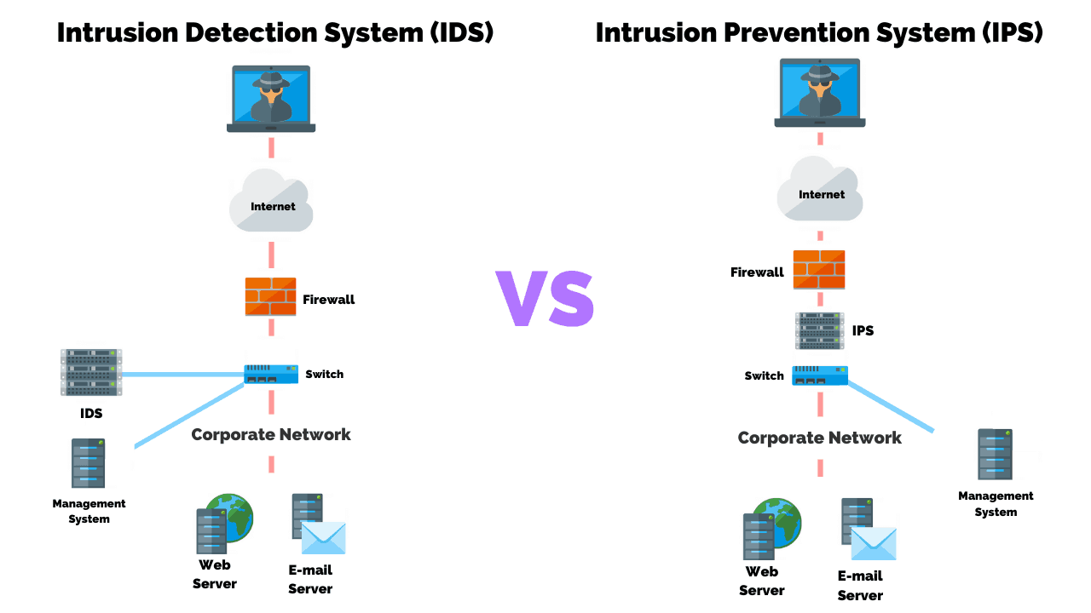

Deployment Types - HIDS & NIDS & WIDS:
- Host based - Monitors activity on a single device/host by being installed lcoally.
- Network based - Monitors activity across a network using remote sensors that reprot back to a central system. Often paired with a security Information & SIEM system for analysis. Often Reverse ARP or Reverse DNS lookups are used to discover the source

Knowledge &Behavior-Based Detection:
- Knowledge Based (Signature Based | Pattern Matching) - Most common form of detection. Uses a database of profiles, or signatures to assess all traffic against.
- Behavior Based (Statistical | Anomaly | Heuristic) - Starts by creating a baseline of behavior for the monitored system/network and then comapres all traffic against that looking for deviations. Can be labeled an AI or Expert system.

Using SNORT
SNORT is an open source network intrusion detection system (NIDS). Snort is a packet sniffer that monitors network traffic in real time, scrutinizing each packet closely to detect a dangerous payload or suspicious anomalies.
- Snort is a widely deployed IDS that is open source
- Includes a sniffer, traffic logger and a protocol analyzer
- Runs in three different modes
  - Sniffer - Watches packets in real time
  - Packet logger - Saves packets to disk for review at a later time
  - NIDS - Analyzes network traffic against various rule sets
- Configuration is in /etc/snort on Linux and C:\snort\etc in Windows; the file is snort.conf.

SNORT basics commands:
Operational modes:
- Snort as Sniffer ---> snort -v
- Snort as Packet logger ---> snort -l
- Snort as NIDS ---> snort -A or snort -c <path_to_conf_file>

Conclusion: Used the snort intrusion detection package to analyze traffic and create a signature to identify problem traffic.

